emoji generation based on textual input using generative adversarial networks

DARSHIL AJAY PAREKH

Final Thesis Report

JUNE 2024

DEDICATION

This project is dedicated to my parents, **Ajay Parekh** and **Deepa Parekh**, whose sacrifices and unwavering support have always motivated me to pursue my dreams. I dedicate this accomplishment to you both, with love and gratitude.

This work is also dedicated to my supervisor, **Mr. Sabyasachi Parida**, for their continued mentorship and inspiration. Thank you for everything.

ACKNOWLEDGEMENTS

I would like to express my deepest gratitude to my supervisor, **Mr. Sabyasachi Parida**, whose invaluable guidance, encouragement, and expertise have been instrumental in the completion of this project. Your constructive feedback and constant support have challenged me to grow academically and personally throughout this journey. Thank you for your patience and unwavering belief in my abilities.

I would also like to thank **upGrad** and my buddy **Harshita Khanna** for her support and guidance thought the journey.

I am also profoundly grateful to my parents, whose unconditional love and endless support have been the foundation of my education. Your belief in me has always been a source of strength, and your encouragement throughout this process has made this achievement possible.

ABSTRACT

With the increase in popularity and its wide variety of uses, emojis have become so necessary and important that sending or responding to a message and commenting or reacting to a post on social media without emoji seems to be impossible. Emoji represents emotions, culture, age, gender, actions, gestures, expressions, sports, foods, places and objects.

Despite the importance the number of emojis are countable and finite in quantity. In this research we will be creating a generative model to generate new unique emojis using short text for more complex and distinction emojis

We will be using the state-of-the-art generative models which consist of mainly two-part generator and discriminator. The generator and discriminator will work one after the other. First the generator will be trained to generate new emojis and after couple of rounds the discriminator will be trained to detect is the emoji is fake or real. This is followed by generator and discriminator rounds. This process continues until the discriminator is not able to detect is the emoji is fake.

This will help the community to generate wide variety of emojis based on the requirement rather than choosing from a finite set of emojis.

This research will help to generate high quality and diverse emojis. It will also help the tech community with the comparison of the different GAN models with different evaluation metrics.

**TABLE OF CONTENTS**

DEDICATION 2

ACKNOWLEDGEMENTS 3

ABSTRACT 4

LIST OF FIGURES 11

LIST OF TABLES 12

LIST OF ABBREVIATIONS 13

CHAPTER 1 14

INTRODUCTION 14

1.1 Background of the Study 14

1.2 Problem Statement 16

1.3 Aim and Objectives 16

1.4 Research Questions 17

1.5 Scope of the Study 17

1.6 Significance of the Study 17

1.6.1 Contributions 17

1.6.2 Beneficiaries 17

1.7 Structure of the study 18

CHAPTER 2 19

LITERATURE REVIEW 19

2.1 Introduction 19

2.2 GAN and Applications 19

2.2.1 What is Generative Adversarial Networks? 19

2.2.2 Basic GAN Architecture and Learning 20

2.2.3 Loss function of GAN 21

2.2.3 Application of GAN 21

2.3 Research on evolution of GAN 23

2.3.1 Conditional Generative Adversarial Networks (cGAN) 23

2.3.2 Wasserstein Generative Adversarial Networks (WGAN) 24

2.3.3 Deep Convolution Generative Adversarial Networks (DCGAN) 25

2.3.4 Stacked Generative Adversarial Networks (StackGAN) 26

2.3.5 Recurrent Generative Adversarial Networks (RGAN) and Recurrent Conditional Generative Adversarial Networks (RCGAN) 27

2.4 Research on Emoji and its Importance 28

2.5 Research on Emoji Dataset 28

2.6 Research on Emoji Generation 29

2.7 Research on Word Embeddings: 30

2.7.1 Key Concepts: 30

2.7.2 Popular Techniques: 30

2.7.2.1 Word2Vec 30

2.7.2.2 GloVe (Global Vectors for Word Representation) 31

2.7.2.3 FastText 32

2.7.2.4 ELMo (Embeddings from Language Models) 32

2.7.2.5 BERT (Bidirectional Encoder Representations from Transformers) 33

2.8.1 Attentional Generative Adversarial Network (Xu et al., 2018) 34

2.8.2 Stack- Generative Adversarial Network (Dhivya and Navas, 2020) 35

2.8.3 Style-CLIP (Patashnik et al., 2021) 36

2.8.4 VQGAN-CLIP (Crowson et al., 2022) 36

2.8.6 StyleGAN-T (Sauer et al., 2023) 37

2.9 Research on Evaluation metrics for GAN 38

2.10 Challenges in GAN 39

2.11 Discussion 40

2.12 Summary 40

CHAPTER 3 41

RESEARCH METHODOLOGY 41

3.1 Introduction 41

3.2 Research Methodology 41

3.2.3 Data preprocessing 41

3.2.3.1 Data Transformation 41

3.2.3.1.1 Normalization and Scaling 41

3.2.3.1.2 Latent Space Manipulation 42

3.2.3.1.3 Word to Vector 42

3.2.3.1.4 Clip embedding 42

3.2.3.2 Data Integration 42

3.2.3.3 Data Cleaning 42

3.2.3.4 Data Reduction 42

3.2.3.5 Data Normalization 42

3.2.4 Architecture 43

3.2.4.1 Introduction 43

3.2.4.2 High-Level Flow Diagram 43

3.2.4.3 Components used in the Generator and Discriminator Layers 43

3.2.4.3.1 Conv2d 43

3.2.4.3.2 ConvTranspose2d 44

3.2.4.3.3 Linear 44

3.2.4.3.4 BatchNorm1d 45

3.2.4.3.5 ReLU (Rectified Linear Unit) 45

3.2.4.3.6 LeakyReLU 45

3.2.4.3.7 Tanh (Hyperbolic Tangent) 46

3.2.4.3.8 Sigmoid 46

3.2.4.4 Generator 46

3.2.4.4.1 Stage I Generator 47

3.2.4.4.2 Stage II Generator 48

3.2.4.5 Discriminator 49

3.2.4.5.1 Discriminator 49

3.2.6 Hyperparameter Tuning 50

3.2.6.1 Why Hyperparameter Tuning Is Important 50

3.2.6.2 Typical Hyperparameters: 50

3.2.6.3 Hyperparameter Tuning Techniques 50

3.2.7 Training and Evaluation 51

3.2.7.1 Training Process 51

3.2.7.1.1 Initialization 51

3.2.7.1.3 Data Preparation 51

3.2.7.1.4 Training Loop 51

3.2.8 Evaluation: 52

3.2.9 Other General Evaluation Metrics 52

3.2.10 Model Selection 52

3.3 Resource Requirements 54

3.3.1 Hardware Requirements 54

3.3.2 Software Requirements 54

3.4 Summary 54

CHAPTER 4 55

IMPLEMENTATION AND ANALYSIS 55

4.1 Introduction 55

4.2 Dataset Description 55

4.3 Dataset Loading 56

4.3 Data Preparation 56

4.3.1 Feature Splitting 56

4.3.2 Data Cleaning 56

4.3.3 Elimination of Variable 56

4.3.4 Transformation into New Feature 57

4.3.5 Splitting of original dataset 57

4.4 Exploratory Data Analysis 58

4.4.1 Univariate Analysis 58

4.4.1.1 Company 58

4.4.1.1 Content 59

4.4.1.1 Description 60

4.4.2 Word Cloud 61

4.4.2.1 Company 61

4.4.2.2 Content 61

4.4.2.3 Description 62

4.5 Hyperparameter 62

4.5.1 lr (Learning Rate): 62

4.5.2 noise_dim (Noise Dimension): 62

4.5.3 projected_embed_dim (Projected Embedding Dimension): 62

4.5.4 batch_size: 62

4.6 Data Visualization 63

4.7 Summary 63

CHAPTER 5 64

RESULTS AND EVALUATION 64

5.1 Introduction 64

5.3 Hyperparameter Tunning Results 64

5.3.2 Key Observations 64

5.3.1 Results 65

5.3.3 Result 12 Evaluation Metric Analysis 66

5.3.4 Result 12 Generated Emojis for Test Set 67

5.4 Word Encoding vs Vector Embedding 68

5.5 Results Analysis for different Vector Embedding Dimension 68

5.8 Results Analysis for Different Learning Rate 69

5.8 Results Analysis for Different Noise Dimensions 70

5.8 Results Analysis for Different Projected Embedding 71

5.8 Results Analysis for Different Batch Size 72

5.6 Stage I Generator Output for the best Hyperparameter 73

5.6.1 Qualitative Evaluation 73

5.6.2 Quantitative Evaluation 76

5.7 Stage II Generator Output for the best Hyperparameter 77

5.7.1 Qualitative Evaluation 77

5.7.2 Quantitative Evaluation 80

5.8 Comparison between metrics 81

5.9 Summary 81

CHAPTER 6 82

CONCLUSIONS AND RECOMMENDATIONS 82

6.1 Introduction 82

6.2 Discussion and Conclusion 82

6.3 Contribution to Knowledge 82

6.4 Future Recommendations 82

REFERENCES 83

APPENDIX A: RESEARCH PROPOSAL 85

Abstract 87

LIST OF FIGURES 89

LIST OF TABLES 90

LIST OF ABBREVIATIONS 91

1. Background 92

2.1 Problem Statement 94

2.2 Related Work 95

2.2.1 Research on Emoji and its Importance 95

2.2.3 Research on Word Embeddings: 96

3. Research Questions 98

3.1 Research Questions 98

4. Aim and Objectives 98

5. Significance of the Study 99

5.1 Contributions 99

5.2 Beneficiaries 99

6. Scope of the Study 99

7. Research Methodology 100

7.1 Introduction 100

7.2 Dataset description 100

7.3 Data preprocessing 100

7.4 Transformation 101

7.5 Models 101

7.6 High Level Flow Diagram 102

7.7 Evaluation metrics 102

8. Requirements or Resources 103

8.1 Hardware Requirement 103

8.2 Software, Web Services and Libraries Requirement 103

9. Research Plan 104

References 105

LIST OF FIGURES

Figure 1 Sample emojis used frequently in informal communication. 10

Figure 2 Emoji used in a feedback form 11

Figure 3 Dataset sample 18

Figure 4 High Level Flow Diagram 20

Figure 5 Research Plan 22

LIST OF TABLES

Table 1 Related works on Methodologies 15

Table 2 State-of-the-art model to be used for emoji generation 20

LIST OF ABBREVIATIONS

GAN Generative Adversarial Network

VQGAN Vector Quantized Generative Adversarial Network

DCGAN Deep Convolution Generative Adversarial Network

CLIP Contrastive Language-Image Pre-Training

AI Artificial Intelligence

ML Machine Learning

RGB Red Green Blue

RGBA Red Green Blue Alpha

CHAPTER 1

INTRODUCTION

1.1 Background of the Study

Emoji is a visual representation of human interaction based on Human emotions, living beings, objects and symbols. These are in widespread use across the internet such as in textual messaging application, social media platforms which are known as informal modes of communication. Below is an image about the most frequently used emojis during informal modes of communication.

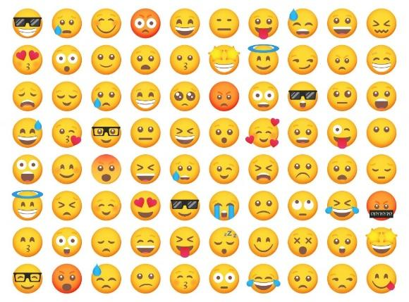

Figure *1* Sample emojis used frequently in informal communication.

According to (Kennison et al., 2024) emojis represent faces with human expressions, objects, animals, and actions.

Emojis are often used to in replacement of words, thus acting as a part of communication and language (Provine et al., 2007). As per the research (Urumutta Hewage et al., 2021) the emojis are static images which are often preserved as human like emotion and expressions. Further, as per (Erle et al., 2022) the communication has greater emotional intensity when we communicated to people using emojis rather than without emojis.

Other application of emojis other than informal communication includes

* Rating/Feedback Form : The feedback forms using emoji instead of stars or numbers. The research has found that the chances of the user giving feedback is higher when emojis are used.
* Providing a Reaction : These days most online applications or websites provide emojis to react to a post, blog, article or tweet.
  + Thumbs up and down emojis are used to like and dislike.
  + Facial emojis are used to express feeling like surprise, wow or shocked.

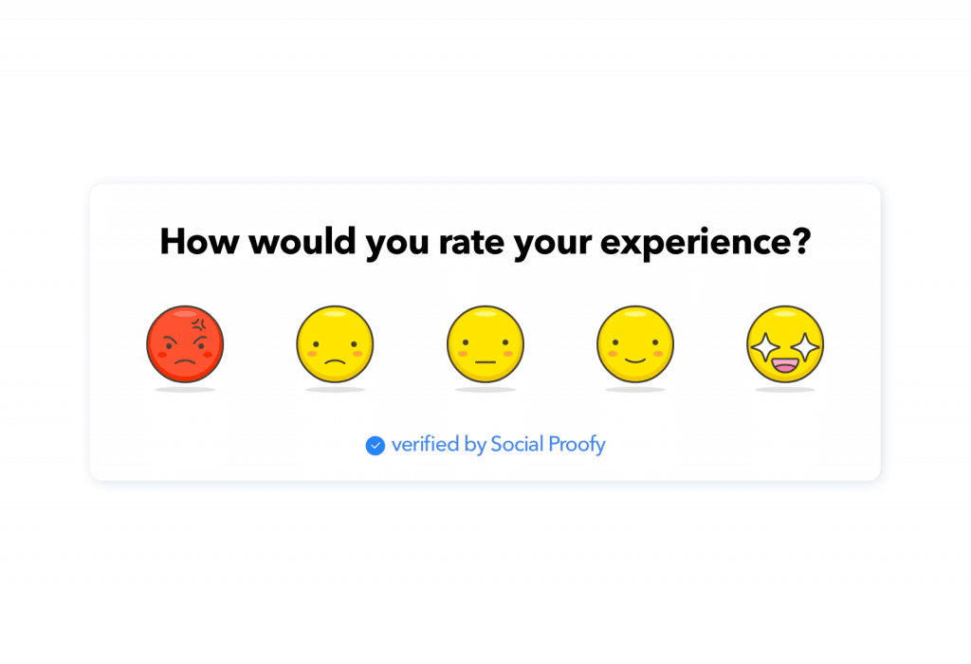

Figure *2* Emoji used in a feedback form

As per the emojipedia.org analysis of over 2.934 billion global tweets between 2017 to 2021, the percentage of tweets with at least one emoji has increased from 13.5% to 21.5%. With the increase of the use of emoji, the demand for newer and customised emoji is increasing. The creation of emoji is a currently is a tedious process of submitting an emoji to Unicode Technical Committee, which takes the final decision for the inclusion, this takes 18-24 months for the complete process Using the state-of-the-art models for generating images using text, we will be able to create new emojis based on the user input.

Prior research has focused on generating facial emojis and emotion based facial emojis. With the state-of-the-art model and architecture, we will be generating not only facial emojis but objects also.

Prior research used techniques like unsupervised learning , Deep Convolution based Generative Adversarial Networks and Conditional Generative Adversarial Networks.

One of the greatest debates on emojis includes whether emoji can be used “as punctuation” or ”after punctuation” which was included in “The Great Emoji Debate”.

In this research we will be creating a state-of-the-art model to generate emojis using emoji content and descriptive information of the emoji and comparing the model with prior models.

We will be looking at the various generative adversarial models :

* DCGAN
* Stacked GAN

1.2 Problem Statement

Currently the process of creating new emojis is a tedious and time-consuming task which takes a couple of days or months to create and years to get approval from the Unicode Technical Committee. Currently there are only 3,664 emojis as per Unicode standard and the need for need and diverse emoji is increasing. Due to this the current library faces limitations in capturing all the human emotion and experiences. This can lead to miscommunication and inadequate representation of culture and identities.

As per the current trend the use of emoji has been steadily increasing in informal conversation and social media. The need for new emojis to be generated quickly based on the text from the user is high. This issue mostly affects the Gen Z generation as they are the ones who use them mostly during the social media platforms, Messaging apps and content creation. It is important as it can improve the quality of the conversation with improved emotions and objects. This solution will have a huge impact on the conversation by improving the quality of the conversation with new and better emojis which can express emotions and objects accurately.

1.3 Aim and Objectives

The aim of this research is to propose a generative model to generate new emojis is to create a new and diverse design based on textual input from the user and compare it with the baseline and previous models which are visually appealing and useful.

Below are the list of research objectives which will be accomplished in this research:

* To create a generative model that can create new high quality and realistic emojis.
* To generate emoji based on the platform of use.
* To compare between the state-of-the-art generative models.
* To evaluate the performance of the emojis generated using the generative models.
* To finetune the various parameters used in the generative model.

1.4 Research Questions

Generate new realistic emoji in real time based on the textual input from the user.

1.5 Scope of the Study

The scope of a study on generating new emojis are as follows:

* Type of architecture : Generative Adversarial Networks
* Data : <https://huggingface.co/datasets/ChengAoShen/emoji_with_text>
* Input : Short textual input
* Output : 64x64 emoji
* Evaluation techniques :
  + Inception Score (Shmelkov et al., 2018)
  + Fréchet Inception Distance (Shmelkov et al., 2018) (Lee et al., 2023)
  + Structural Similarity Index (Mittal et al., 2020)

1.6 Significance of the Study

1.6.1 Contributions

* Offer users a wider range of options to accurately express their emotions and experiences using emoji,
* Reflects the variety of individuals and communities.
* Contribute to the development and application of GANs
* Valuable tool for individuals and communities to create custom emojis

1.6.2 Beneficiaries

* Users of social media platforms.
* Content creators like article and blog writers.
* The AI and ML industry.
* Emoji Designers.
* Unicode and emoji organisations like emojipedia.

1.7 Structure of the study

TODO

CHAPTER 2

LITERATURE REVIEW

2.1 Introduction

GAN or Generative Adversarial Networks belong to generative model family. This model helps to generate new samples from the same distribution from similar sample dataset. Over the last decade, there is significant progress in GAN models. In this chapter we will study the various types of research on GAN and its applications, importance of emoji, various datasets, types and advantages of word embeddings and comparison of various metrics used to test different models.

2.2 GAN and Applications

2.2.1 What is Generative Adversarial Networks?

In 2014 Ian Goodfellow and his colleagues developed the basic GAN model. It was based on zero sum and min max game theory. Here's a simplified explanation of GANs:

* The Forger (Generator): A computer program that starts by making very bad drawings   
  of the emoji
* The Detective (Discriminator): Another computer program that gets shown both real emoji and the Forger's fakes. The Detective tries to tell them apart.

Each time the Detective catches a fake, the Forger learns from its mistakes and tries to make even better fakes. This makes the Detective have to get smarter too.

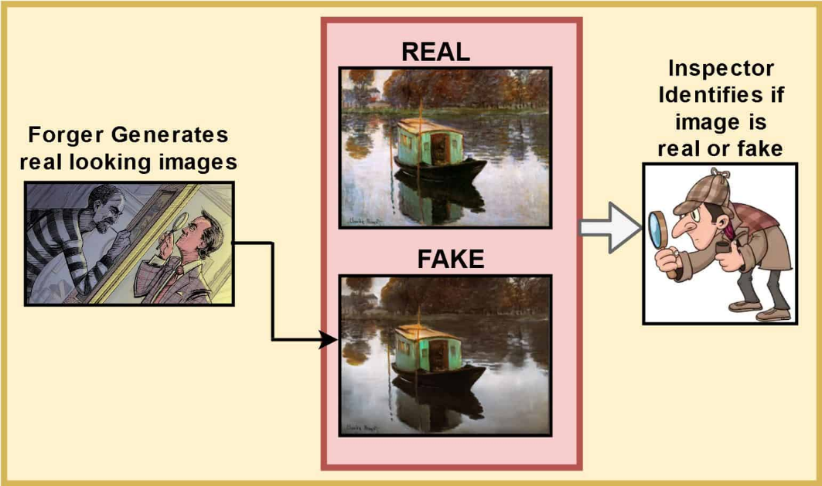

Figure *3* GAN in simplified image

2.2.2 Basic GAN Architecture and Learning

The basic of GAN architecture comprises of one generator and one discriminator. The generator is represented by G and the discriminator is represented by D. The generator takes an input vector z and generate an output which is represented by G(z). Both generator and discriminator consist of neural networks, one to create the required output and other for binary classifier.

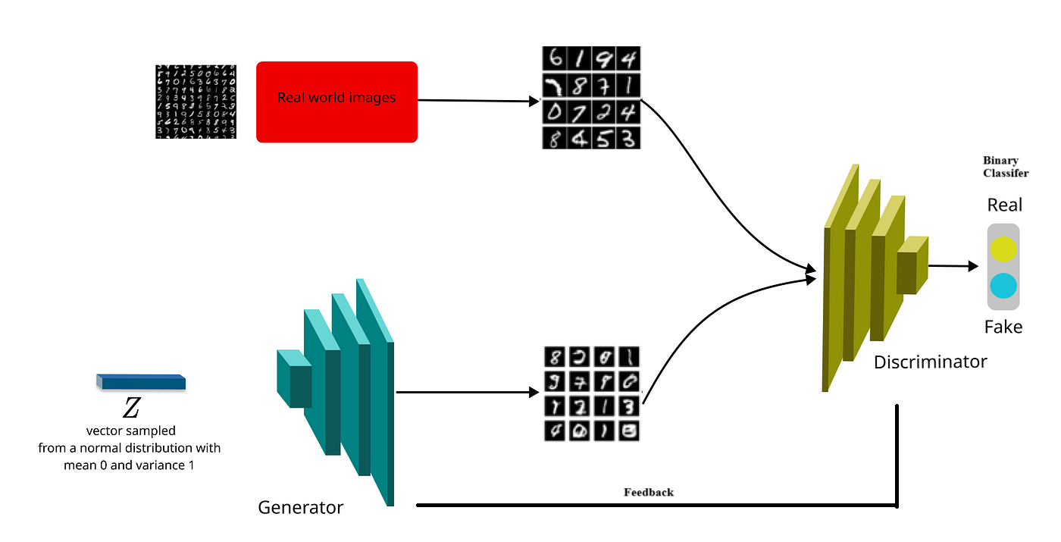

Figure *4* Basic GAN Architecture

The discriminator takes both the real data and the fake data from the generator and tries to decide which one is fake i.e. it models the probability of the fake data is real or not. After each iteration the feedback from the discriminator is sent to the generator to improve the quality of the fake data.

Over a period of time the generator creates better fake data and the discriminator learns identifying the fake images. Both models tries to beat each other due to which the adversarial term come from.

2.2.3 Loss function of GAN

GAN uses minmax loss function to optimize the neural network. The generator minimizes the function and the discriminator maximizes the loss.

$$\min_{g}\max_{d} V\left(D,G\right)$$

$$V(D,G) = E_{x\sim pdata(x)}[logD(x)] + E_{x\sim pz(z)}[log(1 – D(G(z)))]$$

Ex – Expected value over all real data samples

D(x) – Probability of discriminator if x is real

G(z) – Generator output

z – Random noise

D(G(z)) – Probability of discriminator generated data is real

Ez – Expected value over all random data

2.2.3 Application of GAN

Generative Adversarial Networks has received considerable attention due to their ability to generate high-quality synthetic data.

Below are some basic applications in various industries:

* Image Generation and Enhancement
  + Generate new painting based on certain styles or novel artworks.
  + Increase the image resolution without losing any details.
  + Filling in missing or damaged parts of images.
  + Transfer the style of one image (e.g., a photo) to another (e.g., a Van Gogh painting).
* Video and Animation Generation
  + Generate deep fake videos by swapping the faces or creating new sequence.
  + Generate characters for video games and animations
* Text to Image
  + Generate advertising, creative arts, and virtual worlds based on the textual inputs describing the image to be generated.
* Healthcare
  + Generate synthetic medical images for training professionals and enhancing the diversity of training datasets.
  + Improving the quality of medical images such as MRIs or CT scans from incomplete data.
* Data Augmentation
  + Augment face data for improving face detection and recognition algorithms.
* Creative Content Generation
  + Generate new music tracks or compose original pieces.
  + Generate human-like text.
* Gaming and Simulation
  + Generate realistic scenes for video games which reduces the artists time in manually creating them.
  + Generate realistic physical behaviours for use in visual effects and gaming.

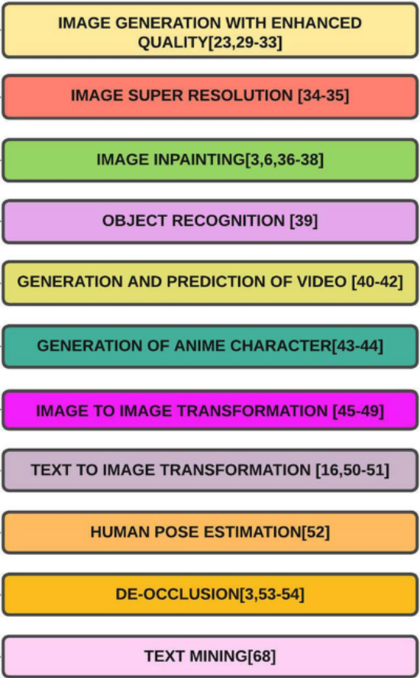

2.3 Research on evolution of GAN

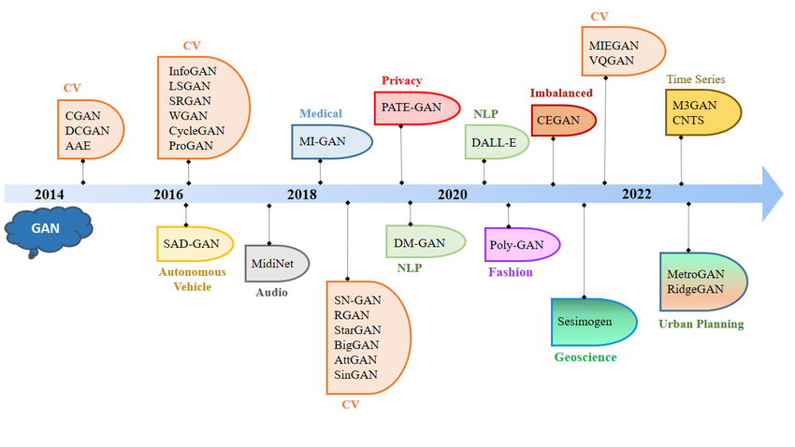

2.3.1 Conditional Generative Adversarial Networks (cGAN)

cGAN are an extension to GAN with additional conditional input along with the noise vector. This gives the generator and discriminator control over the mode of data which is generated. The additional input is denoted by y in the figure below. This can be in any form text, labels or other modalities.

The loss function for cGAN can be represented as:

$$\min_{g}\max_{d} f\left(D,G\right) =E_{x}[logD(x|y)]+E_{z}[log(1 – D(G(z|y)))]$$

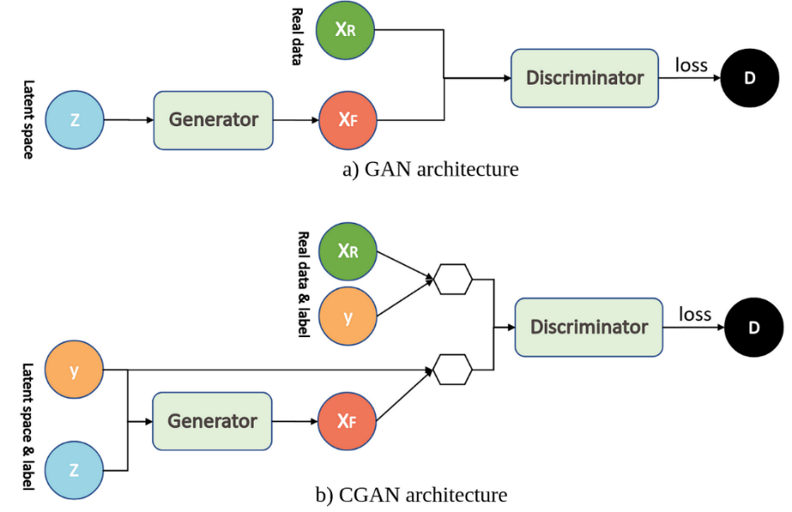

2.3.2 Wasserstein Generative Adversarial Networks (WGAN)

WGAN proposed a new approach to training GAN that addressed some of the inherent challenges of traditional GANs like instability and mode collapse. Instead of using the traditional divergence to measure the difference between the generated and real data it employs the Wasserstein distance. This provides a measure of distance for distributions that may not overlap significantly. It captures how much work is needed to change one distribution into another making it more stable during training.

To ensure that the discriminator/critic maintains the condition required for the Wasserstein distance the weights of the discriminator are constrained to a fixed range which prevents them from growing too big which could lead to instability. The use of Wasserstein distance and weight clipping helps mitigate common problems seen in traditional GAN training, such as mode collapse, where the model generates limited varieties of outputs. WGAN’s framework allows for smoother gradients, leading to more stable learning dynamics.

The loss function for WGAN can be represented as:

$$\min_{g}\max_{d} E_{x\sim p_{r}}[f_{w}(x)]-E_{z\sim p(z)}[f_{w}(G(z))]$$

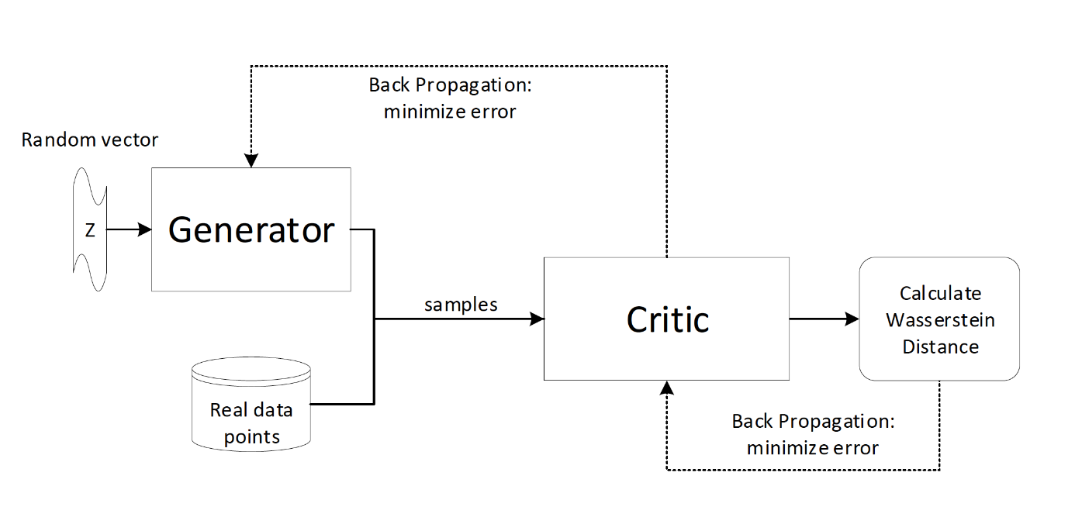

2.3.3 Deep Convolution Generative Adversarial Networks (DCGAN)

DCGANs use deep convolutional neural networks for both the Generator and Discriminator models. The original GAN architecture used only multi-layer perceptron’s or MLPs.

The key features of the DCGANs neural network architecture are:

* The Generator, convolutions are replaced with transposed convolutions, so the representation at each layer of the Generator is successively larger, as it maps from a low-dimensional latent vector onto a high-dimensional image. Replacing any pooling layers with strided convolutions (Discriminator) and fractional-strided convolutions (Generator).
* Use batch normalization in both the Generator and the Discriminator.
* Use ReLU activation in Generator for all layers except for the output, which uses Tanh. Use LeakyReLU activation in the Discriminator for all layers.
* Adam optimizer instead of SGD with momentum.

The loss function for WGAN can be represented as:

$$\min_{g}\max_{d}V(D,G) = E_{x\sim pdata\left(x\right)}[logD(x|y)] +E_{x\sim pz(z)}[log(1 – D(G(z)))]$$

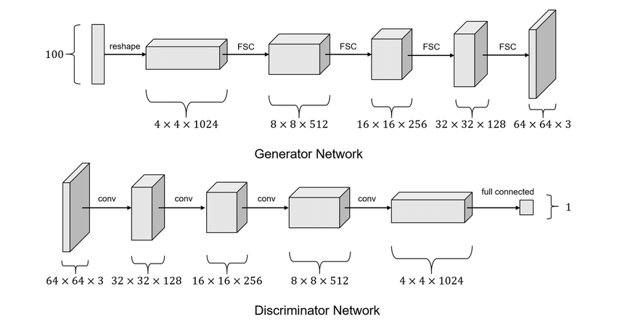

2.3.4 Stacked Generative Adversarial Networks (StackGAN)

StackGAN is a framework designed specifically for generating high-resolution images from textual descriptions. It tackles the challenge of producing detailed images while maintaining coherence with the provided textual input.

The Stack GAN consists of the following components:

* The variable input is converted into a fixed length vector embedding.
* The Stage 1 generator takes the textual input and generates a low-resolution image output.
* The Stage 2 generator takes the textual input along with the low-resolution image generated by the Stage 1 and generate a high-resolution image output.
* Stage 1 and Stage 2 discriminator

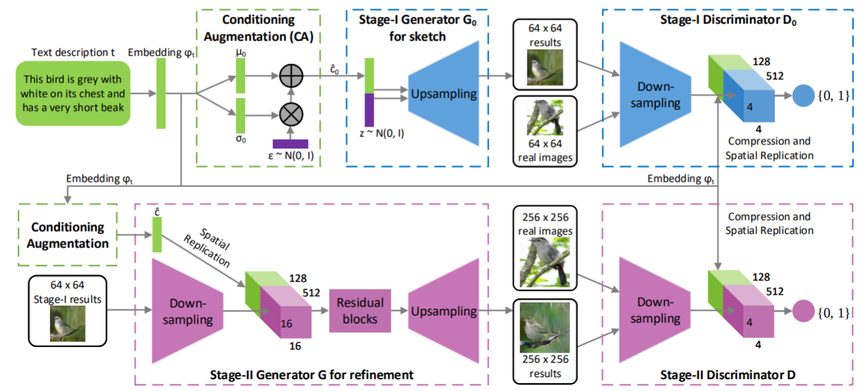

2.3.5 Recurrent Generative Adversarial Networks (RGAN) and Recurrent Conditional Generative Adversarial Networks (RCGAN)

RGAN and RCGAN is used to generate a sequence of data. It use recurrent neural networks for both the Generator and Discriminator models which is the main difference with the DCGAN. Here the RNNs can be a Long Short-Term Memory (LTSM) or Gated Recurrent Unit (GRU) which captures the temporal dependency of input. In case of RCGAN the generator and discriminator receives an addition auxiliary input. Many experiments show effective results while using RGAN and RCGAN for time series data.

The loss function for RCGAN can be represented as:

$$D_{loss}\left(X_{n}, y_{n}\right)= -CE\left({RNN}_{D}\left(X_{n}\right),y_{n}\right)$$

$$G_{loss} (Z_{n}) = D_{loss} ({RNN}_{G}(Z_{n}), 1) = -CE({RNN}_{D}({RNN}_{G}(Z_{n})), 1)$$

Where Xn and yn are the input and zn is the random noise vector

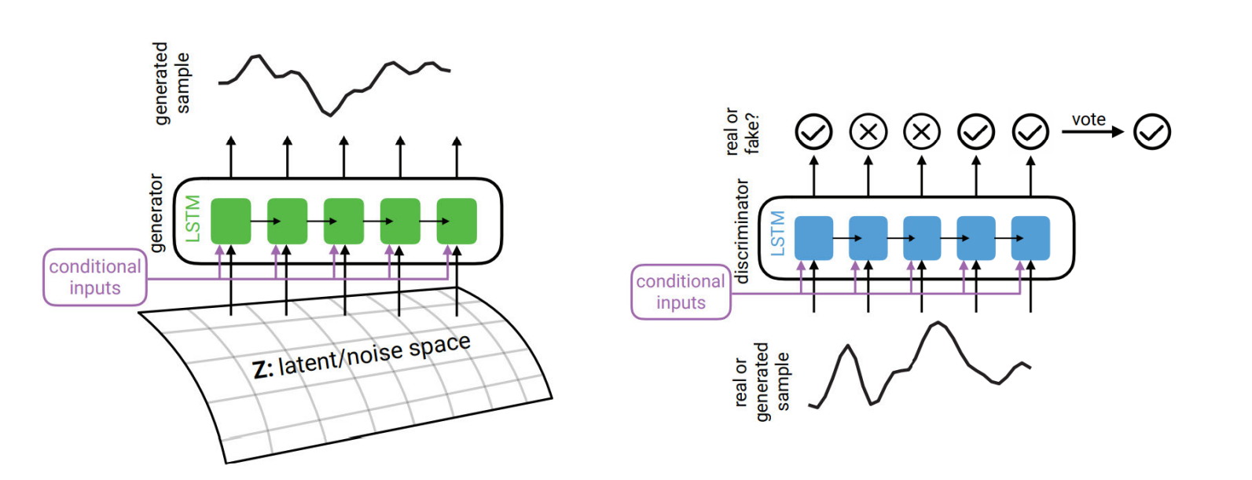

2.4 Research on Emoji and its Importance

Emoji despite being more common in digital communication, is often dependent on characteristics, motives for using them and the context in which they are used (Cavalheiro et al., 2023). Over the past couple of years there has been extensive research in the use and importance of emojis in every life activity. Below are few of the recent research with description and findings:

* The research by (Cavalheiro et al., 2023) try to find the relationship of frequency of the emoji with relationship and individual characteristics. The research also found personal reasons to be one of the relates to high emoji frequency. The research also found age to be directly correlated with emoji frequency which was unexpected.
* The research by (Erle et al., 2022) discusses a creation of emojis in digital communication with the help of their model. The research also found that the emojis can depict the facial expression of the human.
* The research by (Lefebvre et al., 2024) is about the influence of emoji during tip suggestion with the tipping percentage. The research also found significant positive effects of emoji during the tipping.
* The research by (Kennison et al., 2024) relates the personal characteristics with the emojis used in the conversation. The research also found that the men used emojis less often than women. The research also found that users may me using emojis in place of word and used less dictionary words.

2.5 Research on Emoji Dataset

There are very limited datasets for emojis which are labelled and have quality images. Below are the datasets considered which were considered during the start of the research.

* Emoji-dataset on Hugging Face by valhalla

<https://huggingface.co/datasets/valhalla/emoji-dataset>

* Full Emoji Database on Kaggle by ELIAS DABBAS  
  <https://www.kaggle.com/datasets/eliasdabbas/emoji-data-descriptions-codepoints/data>
* Emoji-with-text on Hugging Face by ChengAoShen

<https://huggingface.co/datasets/ChengAoShen/emoji_with_text>

Finalized the 3rd dataset as the quality of the images was good and every image had their respective label.

2.6 Research on Emoji Generation

With the evolution generative models and the importance of emoji there has been couple of research done in the field of emoji generation. It has been noticed that most of the research has been around facial emojis and with a very limited set of them. Below are few of the recent research with description:

* The research (Mittal et al., 2020) uses supervised learning with multimodal input to GAN with U-Net like architecture for the generator to generate realistic hand drawn emojis. This research even though was able to generate the emojis it required the user to draw a rough sketch with the emotion to be given as input, also the dataset used had to be augmented from the facial emojis which don’t depict the real dataset.
* The research (Lee et al., 2023) creates a model which can generate emojis based on emotional degree for more complex and detailed usage on online conversations (Lee et al., 2023). The research uses conditional GAN for the experiment and also compares it with other baseline models. This
* The research (Tang, 2023) used unsupervised learning to generate new emojis using DCGAN which is a combination of Convolution Neural Network and Generative Adversarial Network. This research faced many challenges like after 1000 epochs the accuracy flattens out. The emojis generated where quite blurry and the user had no control over the emojis generated due to unsupervised learning.
* The research (Xu, 2021) used unsupervised learning with optimization techniques with Adam Optimizer to generate new emojis.
* The research (Peng and Zhao, 2021) used an encoder–decoder model, to predict the sequence of emojis based on short text. This research was able to correlate the emojis generated. The model was also able to learn the semantics between the emoji and text description.

Although the above research where able to generate emojis but most of this research had sparse data and limited the scope to generate facial emojis.

2.7 Research on Word Embeddings:

According to the research by (Asudani et al., 2023) the first preference should be given to domain specific embeddings. The research also compares the performance of the various word embedding techniques.

Word embeddings are word representation as vectors in a continuous vector space. This captures semantic relationships between words, making it easier for models to process text. Here’s concepts and techniques used in word embeddings:

2.7.1 Key Concepts:

* Vector Space Model: In this model, words are mapped to points in a high-dimensional space, where similar words are located close to each other.
* Dimensionality: Commonly, embeddings are created with dimensions ranging from 50 to 300, balancing performance and computational efficiency.
* Semantic Relationships: Word embeddings can capture various relationships, such as:
  + Synonymy (e.g., "king" and "queen")
  + Analogies (e.g., "man" is to "woman" as "king" is to "queen")

2.7.2 Popular Techniques:

2.7.2.1 Word2Vec

It is a popular technique for natural language processing that transforms words into numerical vectors. Developed by a team at Google led by Tomas Mikolov, Word2Vec captures semantic relationships between words, enabling computers to understand text better.

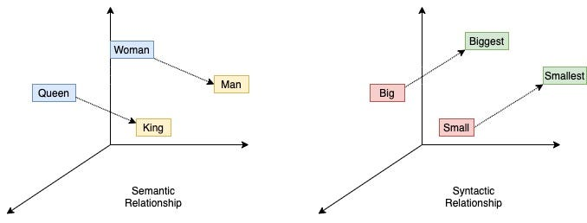

The two training models :

* CBOW (Continuous Bag of Words) - This model used for learning word embeddings, which are dense vector representations of words that capture their semantic and syntactic properties.
* Skip-Gram – This model uses a target word to predict its surrounding context words. It’s particularly effective for learning rare words.

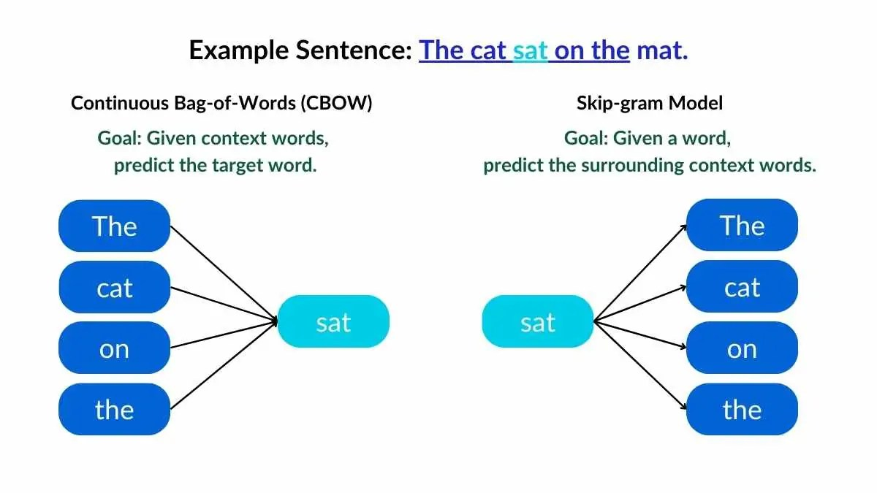

2.7.2.2 GloVe (Global Vectors for Word Representation)

Global Vectors for Word Representation (GloVe) is developed by researchers at Stanford. It is an unsupervised learning algorithm for obtaining vector representations for words. It captures the global statistical information of a sentence in a meaningful way.

GloVe's use of global co-occurrence information allows it to generate embeddings that reflect broader semantic relationships. It uses euclidean distance or  cosine similarity to measuring the linguistic or semantic similarity of the corresponding words.

The output word vectors perform well on various NLP tasks, including analogy and similarity tasks.

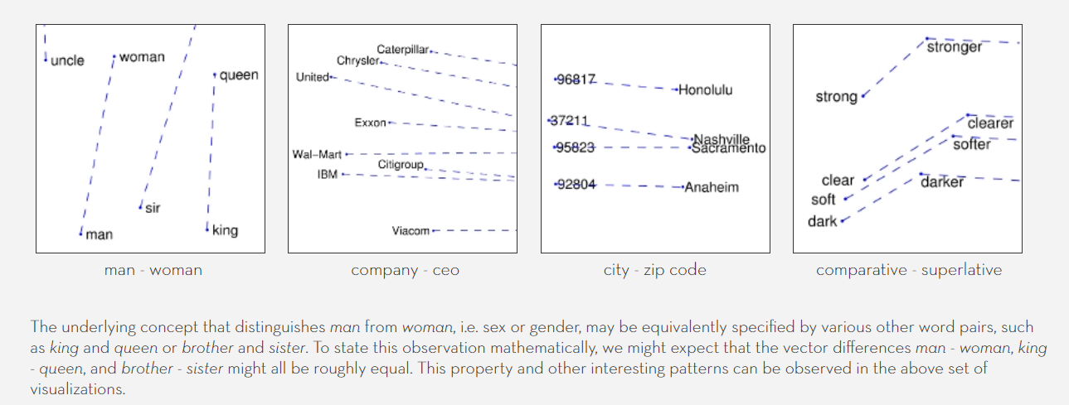

2.7.2.3 FastText

FastText is a sophisticated Word embedding model recently introduced by Facebooks AI Research(FAIR) team performed substantially better than traditional word embeddings by considering subwords. It represents words as a bag of character n-grams (e.g., for the word "apple" it would use "app", "ppl", and "le"). That makes it learn the morphology of word construction and based on its pieces what an English word means. For each word, the model averages the vectors of its n-grams to create a vector for the word, which allows it to embed words that potentially were not even observed during training.

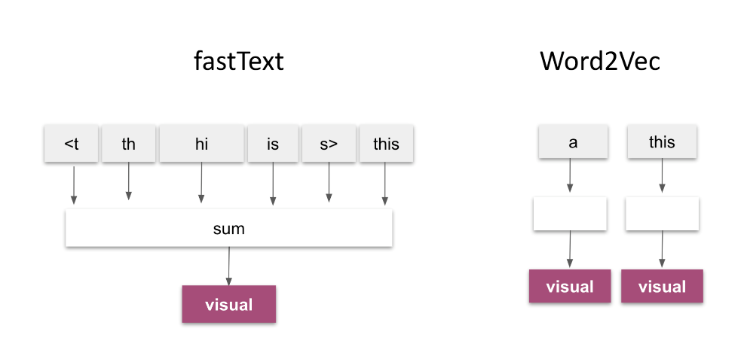

2.7.2.4 ELMo (Embeddings from Language Models)

ELMo is a deep learning model created by the Allen Institute for AI that generates word embeddings. These word embeddings are deep contextualized word representations based on a pre-trained bidirectional language model biLMs.Unlike traditional word embeddings, it captures context in a more sophisticated way.

It creates embeddings based on context of the word. This means that the same word can have different representations depending on its usage in a sentence.

ELMo utilizes a bidirectional Long Short-Term Memory network where it efficiently uses all layers of the bidirectional language model.

ELMo is trained on 1 billion tokens due to which it generates state-of-the-art embedding with contextually aware word representations.

2.7.2.5 BERT (Bidirectional Encoder Representations from Transformers)

BERT is developed by Google and is know for the versatility and performance with benchmark results on GLUE and SQuAD datasets.

It processes text in both directions simultaneously which allows it to capture the full context of a word based on all surrounding words, increasing its understanding of language.

Its encoder utilize self-attention mechanisms which enable the model to weigh the importance of different words in a sentence leading to better representations.

It is trained on large datasets like Wikipedia and BooksCorpus and can be fine-tuned on specific downstream tasks like sentiment analysis and question answering.

It also produces dynamic embeddings based on the context of the word similar to ELMo

Below is the comparison between the different embeddings :

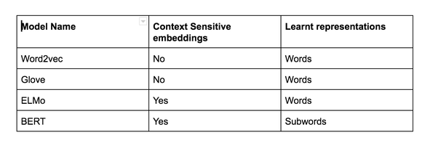

**2.8 Research on Methodology Specific to Text to Image Generation**

Below are the recent methodologies in the text to image domain developed on top of generative adversarial network architecture.

2.8.1 Attentional Generative Adversarial Network (Xu et al., 2018)

Attn-GAN proposed a new GAN with multistage refinement using attention. Each of this multistage attention model gets the most relevant word vectors for generating sub-regions of the image (Xu et al., 2018). This improves the model’s ability to handle complex details and generates more accurate visual elements tied to specific words. This is used to generate images from text input.

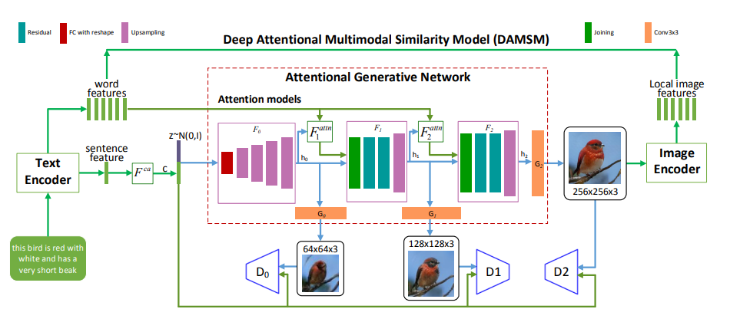

In the research a Stack-GAN was used to increase the resolution of the images generated.

Form the above figure we can see text encoder on the left, attention models in the middle, stacked generators in bottom middle and a discriminator on the right side.

DAMSM ensures that the generated image matches the text by comparing the image features the text features.

The AttnGAN significantly outperformed previous state-of-the-art GAN models, boosting the best reported inception score by 14.14% on the CUB dataset and 170.25% on the more challenging COCO dataset.

2.8.2 Stack- Generative Adversarial Network (Dhivya and Navas, 2020)

The research proposes the use of multiple GAN stacked on top of each other to generate high resolution photo realistic images (Trevisan de Souza et al., 2023). This is used to generate images from text input.



The architecture is divided into two main stages, where each stage focuses on generating and refining the image progressively. Form the above figure we can see Conditioning Augmentation on the left side, stage-I generator in the top centre stage-II generator in bottom centre and the discriminator pair in the right.

The two-stage process allowed the model to first generate a rough image and then progressively refine it which improved the overall quality and alignment with the text description. Also, the Conditioning Augmentation introduced variability in the generated images while still adhering to the given text helping improve diversity.

The Stack-GAN significantly help the other GANs to generate high quality images.

2.8.3 Style-CLIP (Patashnik et al., 2021)

This research proposes CLIP embeddings to allow image editing. The CLIP embeddings share the same latent space hence we can directly compare the text with the images (Trevisan de Souza et al., 2023). This is used to edit images based on text input.

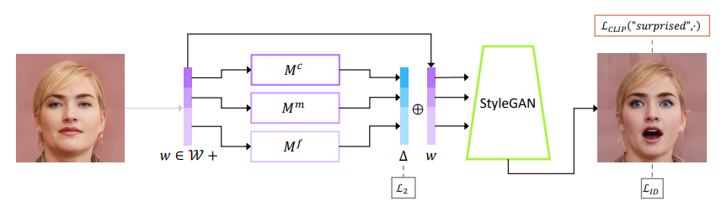

2.8.4 VQGAN-CLIP (Crowson et al., 2022)

This research proposes a model where an encoder is used to create a latent vector which is used by the decoder to create the image. It also uses CLIP embedding with optimization techniques to have high similarity with the text prompt. (Trevisan de Souza et al., 2023). This is used to generate images from text input.

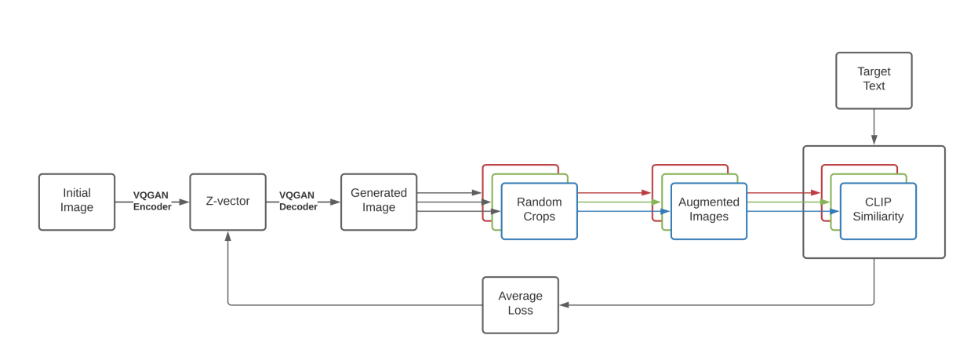

VQGAN-CLIP is a model that combines the powerful image generation capabilities of VQGAN with the understanding of CLIP. This combination allows users to generate excellent images from textual descriptions. Its ability to generate high-quality, creative visuals from text prompts has made it a favorite in the AI art community.

2.8.6 StyleGAN-T (Sauer et al., 2023)

This research proposes a model build from Style GAN-XL mentioned before. The network size of the model is increased to include text information from CLIP encoders.

(Trevisan de Souza et al., 2023). This is used to generate images from text input.

It was created to optimized for fast, large-scale text-to-image synthesis. It is built on the foundation of StyleGAN-XL but introduces significant architectural changes to the generator and discriminator to improve performance in text-conditioned image generation.

Architecture included residual convolutions to stabilize training and increase capacity.

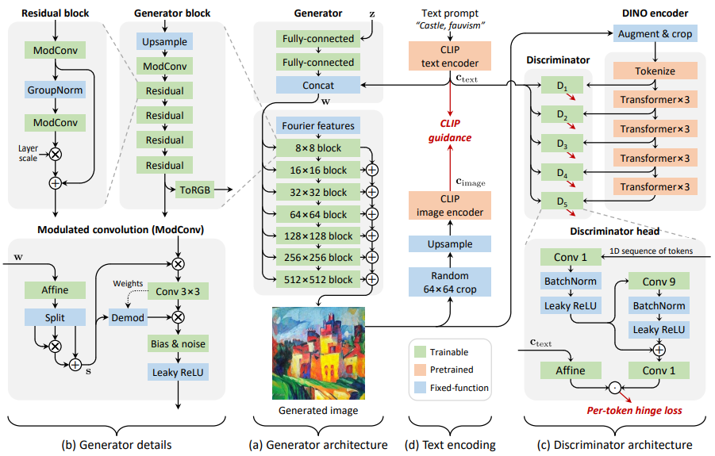

This architecture combined the strengths of StyleGAN with the CLIP model's text guidance. It leverages a Transformer-based discriminator for improved realism and text alignment in image generation. This design allows the model to generate high-quality, text-aligned images with fine details, especially when complex prompts are provided.

2.9 Research on Evaluation metrics for GAN

We can measure the image quality the following metrics are used

* Inception Score (Shmelkov et al., 2018)

It was proposed in 2016 by Salimnas et al where the pretrained InceptionNet model was used to capture the properties of the generated samples. It is used to measure the quality of the images generated by comparing it with the real images from the dataset.

It calculates the KL divergence between the conditional label distribution of sample and marginal distribution of all samples. It access two characteristics mainly one image quality and another image diversity. Inception Score can be represented as :

$$Exp(E_{x}[KL(p(y|x)||p(y))])$$

Where :

p(y|x) – conditional label distribution

p(y) – marginal distribution

KL – Kullback-Leibler

* Fréchet Inception Distance (Shmelkov et al., 2018) (Lee et al., 2023)

It was proposed in 2017 by M Heusel. It is the measure to check how real the image generated are. The score tells how far the generated data vector is from real data vector. InceptionNet model is used to capture and embed features of an input image.

A multivariant Gaussian is used to summarize the embeddings by calculating mean and covariance for generated and real data. FID can be represented as :

$$FID(r,g)={||u_{r}-u_{g}||}_{2}^{2}+ Tr(∑_{r}+∑_{g}–2({(∑_{r}∑_{g})}^{1/2})$$

Where :

(ur, ∑r) – empirical mean and empirical covariance of real data

(ug, ∑g) – empirical mean and empirical covariance of generated data

* Learned Perceptual Image Patch Similarity (Lee et al., 2023)

It was proposed in 2018 by proposed by Richard Zhang and his collaborators. It evaluates the similarity between images which is particularly useful in tasks involving image generation. It is the distance measured between the patches in the latent space.

LPIPS can be represented as :

$$LPIPS(I_{1},I_{2})= ∑1 w_{1}⋅d(f^{l}(I_{1}),f^{l}(I_{2}))$$

Where :

l – Indexes the layers of the CNN

wl – Learned weights for each layer, which adjust the importance of features extracted from different layers

d(.) – Distance metric (often L2 distance) computed on the feature maps

* Structural Similarity Index (Mittal et al., 2020)

TODO

It measures the degradation of the image quality

2.10 Challenges in GAN

Though Generative Adversarial Networks have made significant contribution in various applications but they face several challenges some of them are -

* The generator produces a limited variety of outputs, focusing on a few modes of the data distribution while ignoring others.
* GANs is very difficult to train. The balance between the generator and discriminator is very crucial and can be disrupted .
* The performance of GANs is very sensitive to its hyperparameters, such as learning rates, batch sizes, and network architectures which making tuning a challenging task.
* Training GAN requires huge resources in both RAM and VRAM.
* The discriminators can overfit on training data which makes it harder for the generator to learn.

Addressing these challenges continues to be an active area of research in the field of machine learning and deep learning.

2.11 Discussion

Current discussions around Generative Adversarial Networks (GANs) in 2023 and beyond focus on several key areas of research and application:

* Innovate GAN architectures like DALL E and DALL E 2 which used CLIP to generate high quality images.
* Improving GAN Stability and Performance such as mode collapse and vanishing gradients. Solutions such as spectral normalization, Wasserstein loss, and adaptive learning schedules are being further refined.
* Multi-scale GAN architectures like BigGAN and StyleGAN continue to set benchmarks in quality and diversity of generated images.
* Ethical Concerns and Responsible AI is one of the most disscusion areas particularly after the rise of deepfakes. Discussions in 2023 emphasize the need for better detection techniques, regulatory frameworks, and responsible AI use cases to mitigate harmful applications.

2.12 Summary

TODO

CHAPTER 3

RESEARCH METHODOLOGY

3.1 Introduction

In this chapter we will be going through the end-to-end 2-stage Stacked Generated Adversarial Network architecture along with data preprocessing, data cleaning, data transformation techniques used and the evaluation metrics used in the research.

3.2 Research Methodology

In this section, we will cover the design experiments to generate emoji using textual input.

3.2.3 Data preprocessing

Preprocessing data is a crucial phase in the data mining process. It describes the processes of preparing data for analysis through integration, transformation, and cleaning. Enhancing the data's quality and adapting it to the particular data mining task is the aim of data preprocessing.

3.2.3.1 Data Transformation

This entails formatting the data so that it can be analysed properly. Normalization, standardization, and discretization are common methods used in data transformation. While standardization is used to change the data to have a zero mean and unit variance, normalization is used to scale the data to a common range. Continuous data can be discretized using the discretization process.

3.2.3.1.1 Normalization and Scaling

Transforming data values into a standard range or scale. Scaling values between a specified range (e.g., 0 to 1) is known as min-max normalization. Standardizing data to have a mean of 0 and a standard deviation of 1 is known as Z-score standardization. Decimal scaling, z-score normalization, and min-max normalization are some of the methods.

3.2.3.1.2 Latent Space Manipulation

Latent space is the hidden layers in the architecture which can be seen as compressed input. As proposed in (Yang et al., 2021) we can use latent space factorization or manipulations to change the attributes of the image.

3.2.3.1.3 Word to Vector

The text description for the emojis will be converted to vector representation.  
They capture the meaning and their usage.

3.2.3.1.4 Clip embedding

The images and text vectors share the same latent space which is helpful in direct comparison of the both

3.2.3.2 Data Integration

This entails merging information from several sources to produce a single dataset. Because it involves handling data with various formats, structures, and semantics, data integration can be difficult. Data integration can be accomplished by using methods like record linkage and data fusion.

3.2.3.3 Data Cleaning

This entails locating and fixing mistakes or discrepancies in the data, including duplicates, outliers, and missing values. Data cleaning can be accomplished with a variety of methods, including imputation, removal, and transformation.

3.2.3.4 Data Reduction

This entails shrinking the dataset without sacrificing any of the crucial data. Techniques like feature selection and feature extraction can be used to reduce data. While feature extraction entails converting the data into a lower-dimensional space while maintaining the crucial information, feature selection entails choosing a subset of pertinent features from the dataset.

3.2.3.5 Data Normalization

Scaling the data to a common range, like between 0 and 1 or -1 and 1, is required for this. To manage data with various scales and units, normalization is frequently utilized. Decimal scaling, z-score normalization, and min-max normalization are examples of common normalization methods.

3.2.4 Architecture

3.2.4.1 Introduction

Here's a simplified explanation of GANs:

* The Forger (Generator): A computer program that starts by making very bad drawings   
  of the emoji
* The Detective (Discriminator): Another computer program that gets shown both real emoji and the Forger's fakes. The Detective tries to tell them apart.

Each time the Detective catches a fake, the Forger learns from its mistakes and tries to make even better fakes. This makes the Detective have to get smarter too.

3.2.4.2 High-Level Flow Diagram

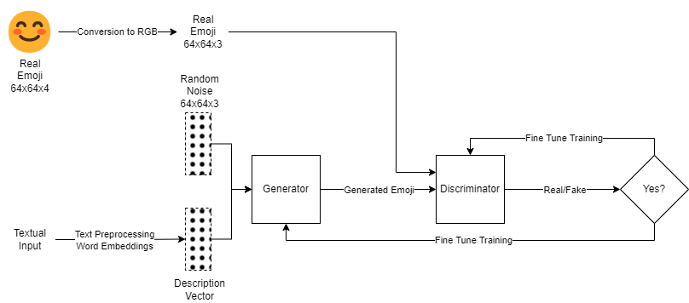

Figure *5* High Level Flow Diagram

3.2.4.3 Components used in the Generator and Discriminator Layers

3.2.4.3.1 Conv2d

Conv2d is a core layer of convolutional neural networks (CNNs) that is intended primarily for image processing and analysis. It applies a filter, sometimes referred to as a kernel, to the input image by swiping it across the image and carrying out additions and multiplications at the element level. A fresh feature map that highlights particular motifs or characteristics in the picture is the end product.

Important variables:

* Input Shape: The image's measurements (height, width, and channels).
* Filters: How many filters should be used. Every filter picks up a unique pattern.
* Kernel Size: The filter's spatial dimensions (width, height).
* Stride: The amount of pixel shift that the filter experiences with each step.
* Padding: The amount of zero padding applied to the source image in order to regulate the size of the output.

3.2.4.3.2 ConvTranspose2d

ConvTranspose2d, commonly referred to as deconvolution, is a layer that is frequently used to upsample feature maps in generative models, including autoencoders and generative adversarial networks (GANs). In essence, it is Conv2d's inverse operation.

Important variables:

* Input Shape: The image's measurements (height, width, and channels).
* Output Padding: The quantity of padding that is used to regulate the size of the output feature map.
* Stride: The amount of pixel shift that the filter experiences with each step.
* Kernel Size: The filter's spatial dimensions (width, height).
* Filters: How many filters should be used. Every filter picks up a unique pattern.

3.2.4.3.3 Linear

An essential part of neural networks is a linear layer, sometimes referred to as a dense layer or a fully connected layer. Neurons in one layer are connected to neurons in the layer below using it. Every neuron in the input layer is connected to every neuron in the output layer in a linear layer.

Important variables:

* Input Shape: The number of neurons in the input layer.
* Output Shape: The number of neurons in the output layer.
* Weights: A weight matrix that links the input and output neurons.
* Biases: The weighted sum of the input neurons plus a vector of biases.

3.2.4.3.4 BatchNorm1d

A common normalization layer in deep neural networks, particularly in convolutional neural networks (CNNs), is BatchNorm1d. Normalization of batch neuron activations contributes to increased training stability and convergence of deep networks.

Important variables:

* Num_features: The tensor's input feature count.
* Affine: Whether or not to apply shifting and scaling affine transformations following normalization.
* Track_running_stats: Indicates whether to monitor the input data's running mean and variance.
* Momentum: The running mean and variance are updated using this momentum.

3.2.4.3.5 ReLU (Rectified Linear Unit)

One popular activation function in deep learning neural networks is ReLU. It gives the model nonlinearity, which enables it to recognize intricate patterns in the data.

Formula: ReLU(x) = max(0, x)

3.2.4.3.6 LeakyReLU

One variation of the ReLU activation function that deals with the "dying ReLU" issue is called Leaky ReLU. Leaky ReLU permits a slight negative slope when the input is negative, whereas ReLU sets all negative inputs to zero.

Formula: LeakyReLU(x) = max(0, x) + alpha * min(0, x)

where alpha is a small positive constant, typically set to a value between 0.01 and 0.3.

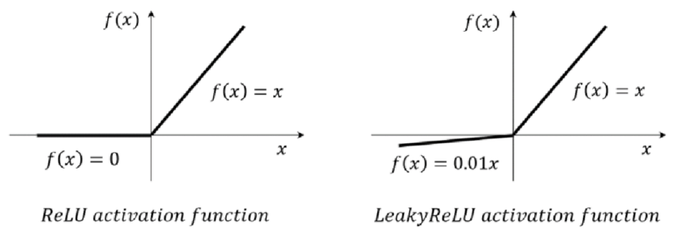

3.2.4.3.7 Tanh (Hyperbolic Tangent)

Tanh is another commonly used activation function in deep learning neural networks. It is a sigmoid-like function that maps input values to the range of -1 to 1.

Formula: Tanh(x) = (e^x - e^-x) / (e^x + e^-x)

3.2.4.3.8 Sigmoid

The sigmoid activation function is a widely used nonlinear function in deep learning neural networks. It maps input values to the range of 0 to 1, making it suitable for tasks involving binary classification or probability estimation.

Formula: Sigmoid(x) = 1 / (1 + e^-x)

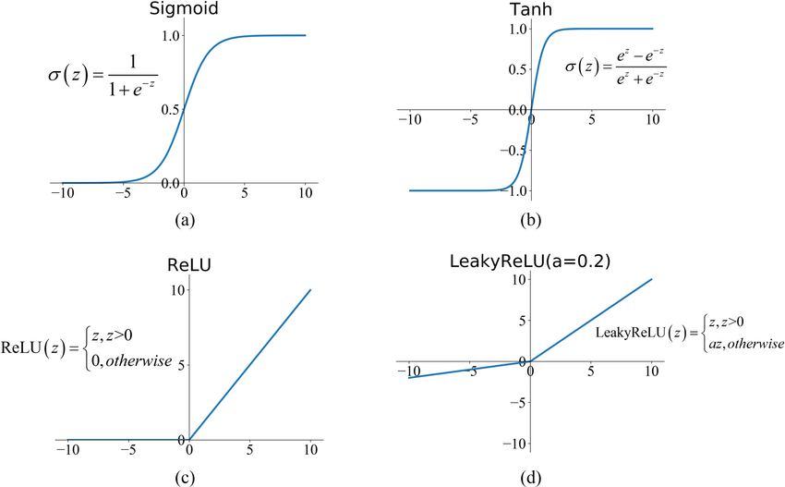

3.2.4.4 Generator

The generator creates synthetic data (such pictures) using a random noise vector, which is usually sampled from a Gaussian or uniform distribution. In an attempt to "fool" the discriminator, its objective is to provide outputs that are as near to genuine data as feasible.

The generator gains the ability to map the distribution of noise into the distribution of data (cat pictures, for example).

In a GAN, the generator's goal is to create artificial samples that are convincing enough to trick the discriminator. To do this, the generator minimizes its loss function, JG. When the discriminator has a high likelihood of classifying the produced samples as real, or when the log probability is maximized, the loss is reduced. The equation that follows is provided below:

JG​=−1/m Σi=1 m​logD(G(zi​))

Where,

JG​ - measure how well the generator is fooling the discriminator.

log 𝐷(𝐺(𝑧𝑖)) - log probability of the discriminator being correct for generated samples.

3.2.4.4.1 Stage I Generator

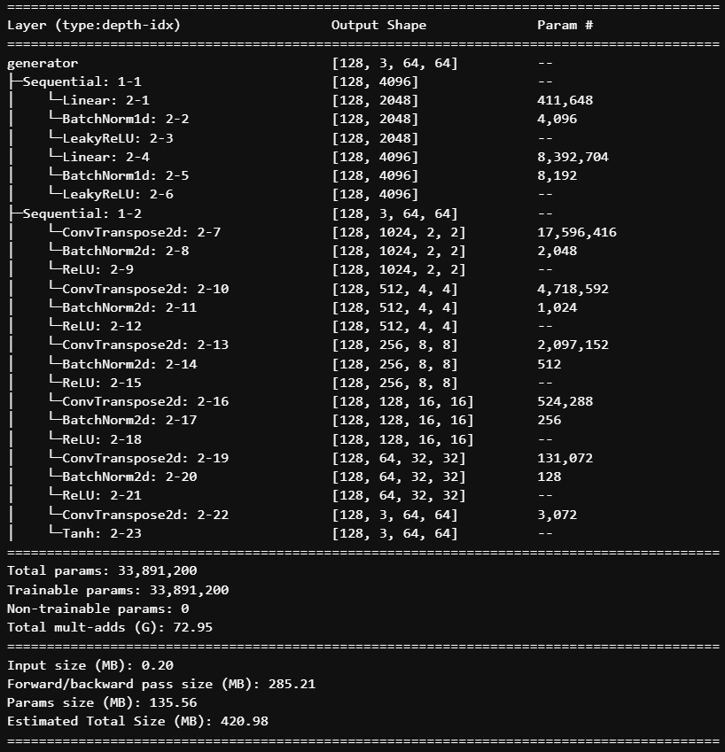

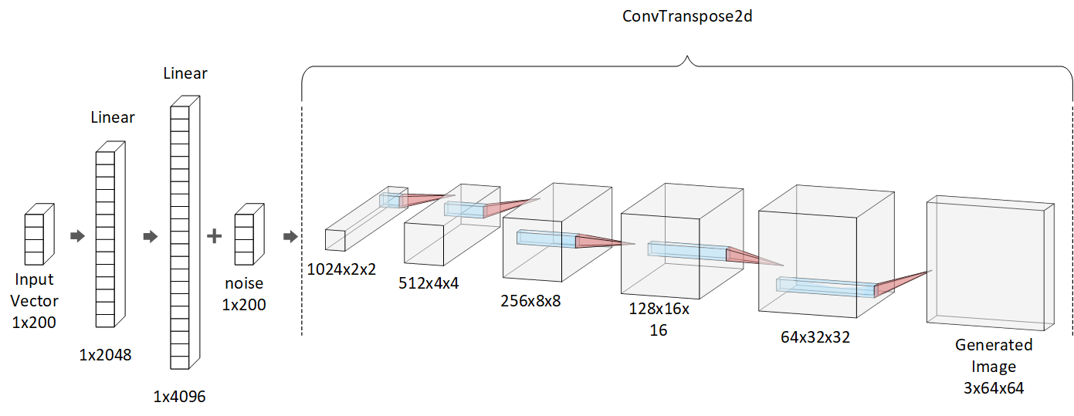

3.2.4.4.2 Stage II Generator

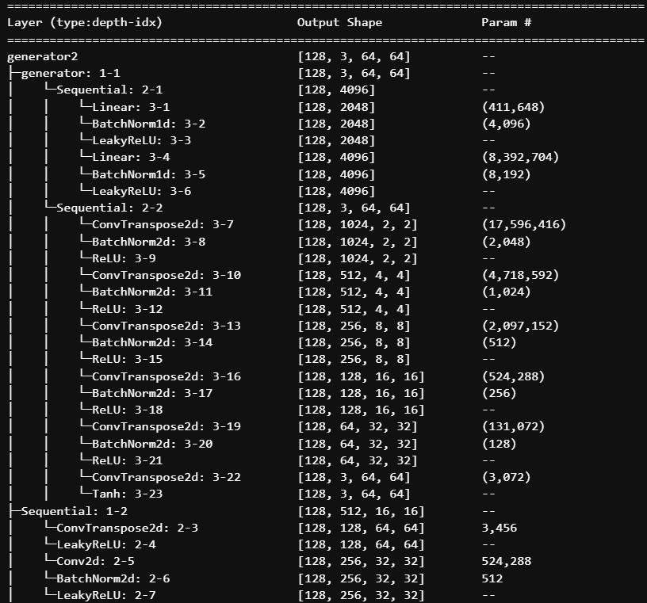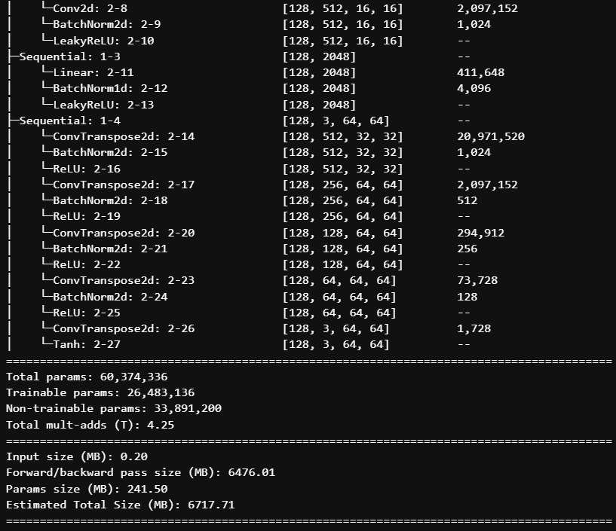

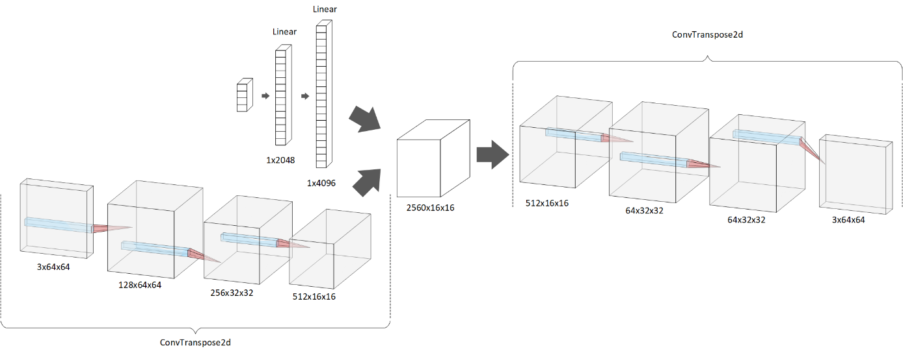

3.2.4.5 Discriminator

By differentiating between genuine data (from the actual dataset) and bogus data (from the generator), the discriminator serves as a classifier.

Its objective is to accurately identify if the input is bogus or real.

Feedback about how "real" or "fake" the created data seems is given to the generator via the discriminator.

The discriminator reduces the negative log likelihood of correctly classifying both produced and real samples. With the following equation, this loss motivates the discriminator to correctly classify produced samples as real and bogus samples.

JD​=−1/m Σi=1 m​logD(xi​)–1/m ​Σi=1m​log(1–D(G(zi​))

Where,

JD​ - assesses the discriminator’s ability to discern between produced and actual samples.

𝑙𝑜𝑔𝐷(𝑥𝑖) - log likelihood that the discriminator will accurately categorize real data.

𝑙𝑜𝑔(1−𝐷(𝐺(𝑧𝑖))) - log chance that the discriminator would correctly categorize generated samples as fake.

3.2.4.5.1 Discriminator

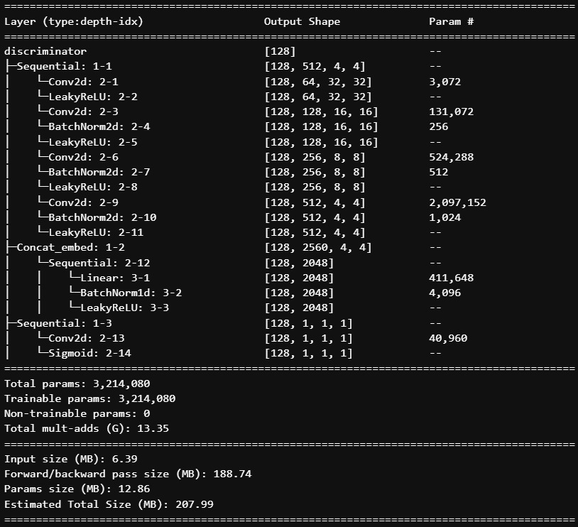

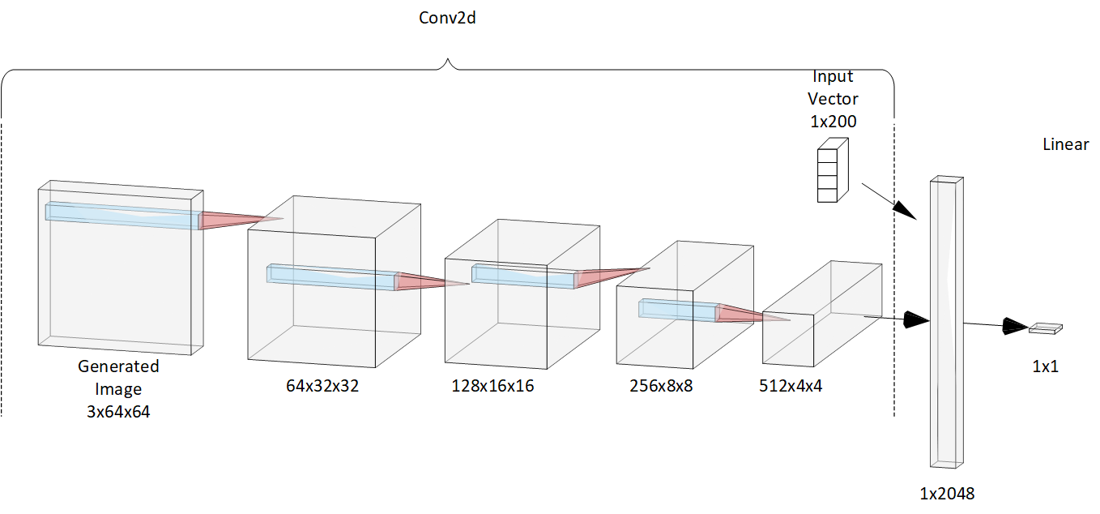

3.2.6 Hyperparameter Tuning

The process of choosing the ideal set of parameters for a model is known as hyperparameter tuning. These parameters are manually set prior to training; they are not learned from the data during training.

3.2.6.1 Why Hyperparameter Tuning Is Important

A model's performance can be greatly enhanced by fine-tuning its hyperparameters, which can result in improved outcomes for tasks like generation, regression, and classification. By preventing overfitting, optimal hyperparameters guarantee that the model will perform well when applied to previously unseen data. By preventing pointless training runs, effective hyperparameter tuning can conserve computer resources.

3.2.6.2 Typical Hyperparameters:

* Learning Rate: Determines how big of an optimization step to take.
* Batch Size: The quantity of samples handled during every training cycle.
* Epochs: The quantity of full dataset iterations.
* Regularization: To avoid overfitting, employ strategies such as L1 or L2 regularization.
* The number of layers, neurons per layer, and activation functions that make up a network architecture.
* Optimizer: Model weight updating algorithm (e.g., SGD, Adam, RMSprop).

3.2.6.3 Hyperparameter Tuning Techniques

* Grid Search: A brute-force approach where you try all combinations of hyperparameters within a specified grid.
* Random Search: A more efficient method where you randomly sample hyperparameters from a specified distribution.

3.2.7 Training and Evaluation

3.2.7.1 Training Process

A generator and a discriminator neural network compete with one another during the training process of a Generative Adversarial Network (GAN). Below is a summary of the essential steps:

3.2.7.1.1 Initialization

* Set the weights of the generator and discriminator networks at random.
* Choose the number of epochs, batch size, learning rate, and other pertinent hyperparameters.

3.2.7.1.3 Data Preparation

* Make sure your training data is loaded in a format that the GAN can understand.
* To increase training stability, normalize the data to a specified range (0 to 1).

3.2.7.1.4 Training Loop

For each epoch:

1. **Sample Real Data:** Retrieve a batch of real samples from the training dataset.
2. **Generate Fake Data:** Feed random noise into the generator to generate a batch of fake samples.
3. **Train Discriminator:**
   1. Feed both real and fake samples to the discriminator.
   2. Calculate the discriminator loss using a binary cross-entropy loss function.
   3. Update the discriminator's weights using an optimizer (e.g., Adam, RMSprop).
4. **Train Generator:**
   1. Feed random noise into the generator to generate fake samples.
   2. Calculate the generator loss using a binary cross-entropy loss function, aiming to fool the discriminator.
   3. Update the generator's weights using an optimizer.
      1. Evaluation:

Employ metrics to measure the image quality :

* Inception Score (Shmelkov et al., 2018)   
  It is used to measure the quality of the images generated by comparing it with the real images from the dataset.
* Fréchet Inception Distance (Shmelkov et al., 2018) (Lee et al., 2023)  
  It is the measure to check how real the images generated are.
* Structural Similarity Index (Mittal et al., 2020)  
  It measures the degradation of the image quality.
* Human Evaluation  
  Periodically visualize the generated samples to assess their quality and progress.

3.2.9 Other General Evaluation Metrics

* Discriminator Loss: This plot shows the loss of the discriminator model over time. Ideally, the discriminator loss should decrease, indicating that the discriminator is becoming better at distinguishing real and fake images.
* Generator Loss: This plot shows the loss of the generator model over time. The generator loss should decrease as the generator becomes better at producing realistic images that can fool the discriminator.
* Discriminator Output for Real Images (D(X)): This plot shows the discriminator's output for real images. It should ideally be close to 1, indicating that the discriminator is confident that the images are real.
* Discriminator Output for Fake Images (D(G(X)): This plot shows the discriminator's output for fake images generated by the generator. It should ideally be close to 0, indicating that the discriminator is confident that the images are fake.

3.2.10 Model Selection

In this research, we will be using a StackGAN model where we will be comparing the emojis generated by Stage 1 with the emojis generated by Stage 2.

The StackGAN architecture's hierarchical structure and capacity to generate high-quality outputs make it an appealing option for emoji creation. The multi-stage approach of this model enables the generation of images to be refined gradually beginning with a coarse representation and progressively adding fine details.

Furthermore, StackGAN's capacity to produce high-resolution images is especially helpful for creating emojis because it produces symbols that are aesthetically pleasing and easily identifiable. The model's versatility further improves its fit for this task by enabling us to experiment with a large variety of emoji styles and designs.

3.3 Resource Requirements

3.3.1 Hardware Requirements

Initial research done on a laptop with the following configuration

CPU : i7 8th Gen

RAM : 16GB

GPU : 4GB Nvidia GPU

The later part of the research was done in a Jarvis cloud VM with the following configuration

RAM: 32GB

GPU: 16GB Nvidia GPU

3.3.2 Software Requirements

* Python
* PyTorch
* Matplotlib
* Pandas
* Numpy
* Easydict
* Datasets
* Pillow
* Wordcloud
* Nltk
* opencv-python
* Jupyter Notebook and Jupyter Lab
* Git Version Control

3.4 GitHub Repository

TODO

3.5 Summary

TODO

CHAPTER 4

IMPLEMENTATION AND ANALYSIS

4.1 Introduction

In the previous chapter the research methodology employed in this study. In this chapter we will focus on the implementation and analysis derived from the methods explained in the previous chapter.

4.2 Dataset Description

The dataset (ChengAo Shen and Siyuan Mu, 2023) is uploaded on Hugging Face. The dataset was in parquet format which is an open-source column-oriented data storage known for efficiently storing and retrieving large volumes of complex data.

This dataset consists of 47192 rows and 2 columns (image, text). Each row consisted of an emoji and its text description.

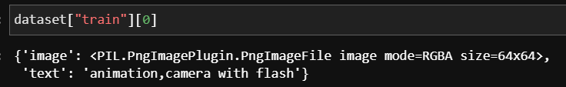

Each image is of shape 64*64 and has 4 channels (RGBA) and the text description format is app or company, emoji content and description information which are comma separated.

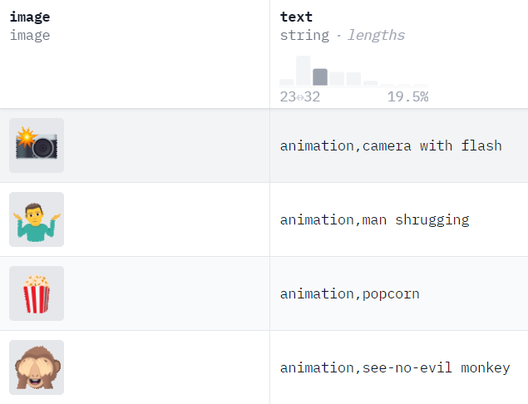

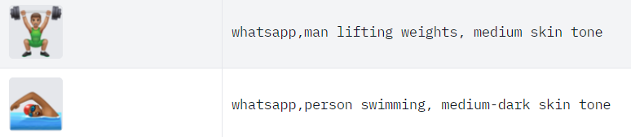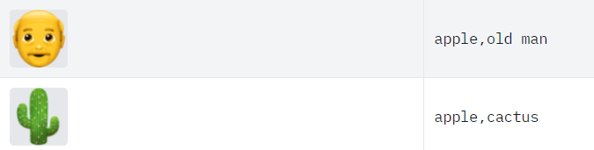

Figure *6* Dataset sample

4.3 Dataset Loading

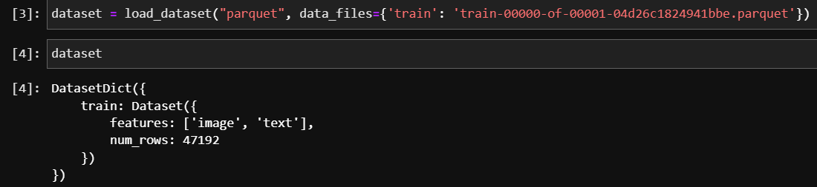

To load the dataset, we have used datasets library from Hugging Face which will load the data from parquet file to Dataset Dictionary type.

4.3 Data Preparation

4.3.1 Feature Splitting

The text column is split into 3 new columns based on the following format

COMPANY, EMOJI CONTENT, DESCRIPTION

To text is split based on commas and trimmed to remove any spaces at the start or end.

4.3.2 Data Cleaning

The stop words are removed from emoji content and the description column to improve the accuracy of the model.

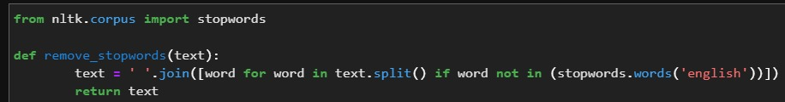

To remove stop words from text we have used Natural Language Toolkit (nltk) library.

4.3.3 Elimination of Variable

After splitting, the previous text column is eliminated as the required data is captured in other columns.

4.3.4 Transformation into New Feature

The emoji context and the description column are combined to create a new feature which will converted into embedding for model input.

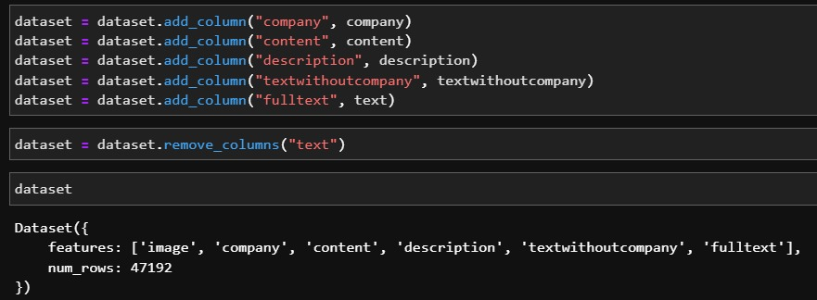

4.3.5 Splitting of original dataset

The dataset is split into two sets train and test with train containing 70% and test containing 30%.

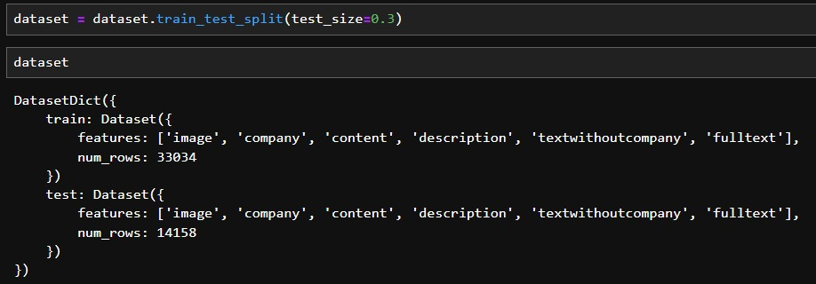

4.4 Exploratory Data Analysis

4.4.1 Univariate Analysis

4.4.1.1 Company

The openmoji company is the most frequent, with a count significantly higher than any other company. Apple and Samsung follow closely behind openmoji, suggesting they also have a large number of emoji associated with them. Popular social media platforms like WhatsApp, Twitter, Facebook, and Google also have a considerable presence in the dataset. Companies like Microsoft, Microsoft Teams, and Telegram, which are primarily known for their technology products, also have a noticeable number of emoji associated with them.

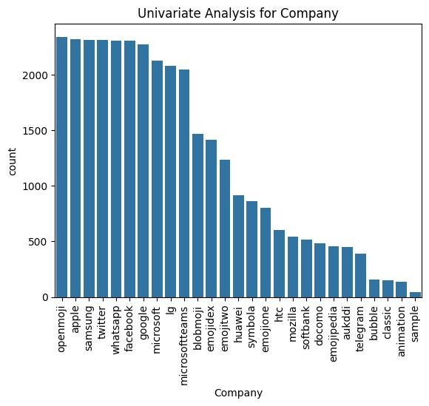

4.4.1.1 Content

The "flag" content is the most frequent, with a significantly higher count than any other content type. Content related to people, such as "person," "woman," "man," and various hand gestures, is also prevalent. Content depicting family and relationships, like "family," "woman and man holding hands," and "people holding hands," is represented.

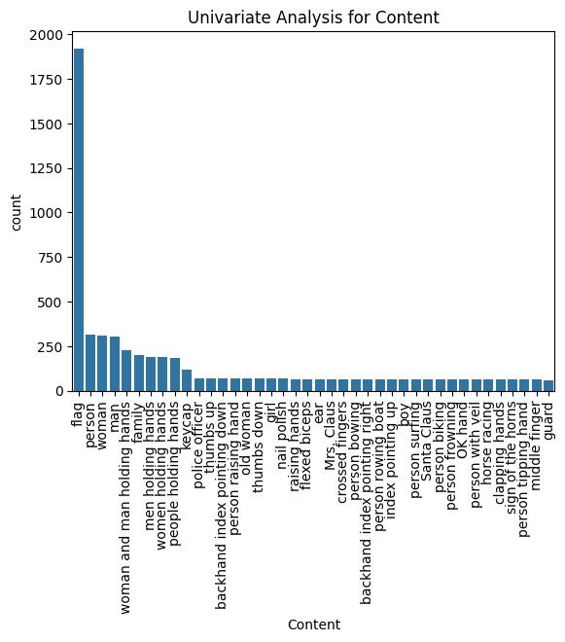

4.4.1.1 Description

The "light skin tone" category is the most frequent, with a significantly higher count than any other skin tone. The description column is dominated by the skin tone types with “light skin tone”, “medium-light skin tone”, “medium skin tone”, “medium-dark skin tone” and “dark skin tone”.

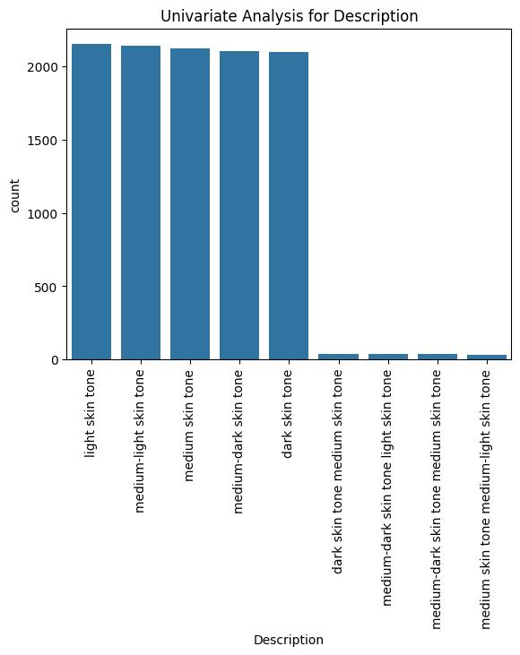

4.4.2 Word Cloud

4.4.2.1 Company

The top companies with highest emojis are openmoji, apple twitter, samsung, whatsapp and facebook.

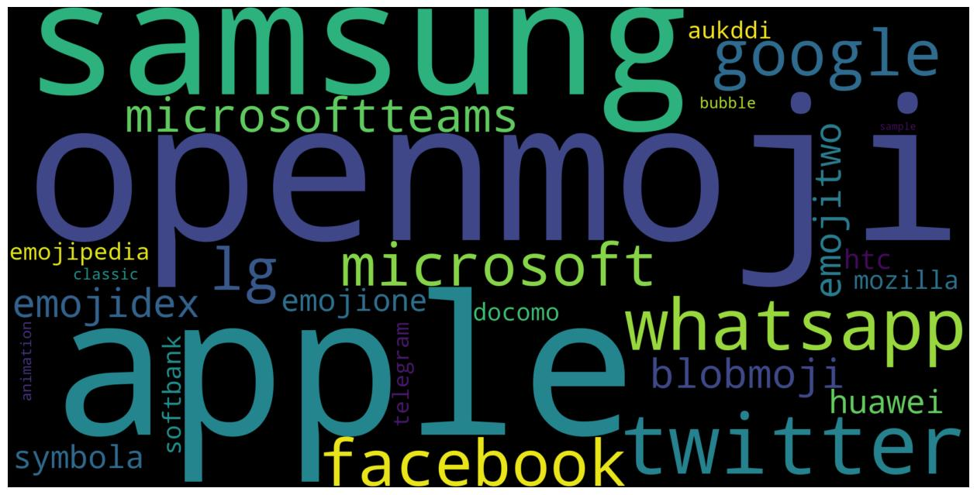

4.4.2.2 Content

The top words in content with the highest frequencies are flag, man, holding hands, person, backhand index, men holding, woman, Japanese and face.

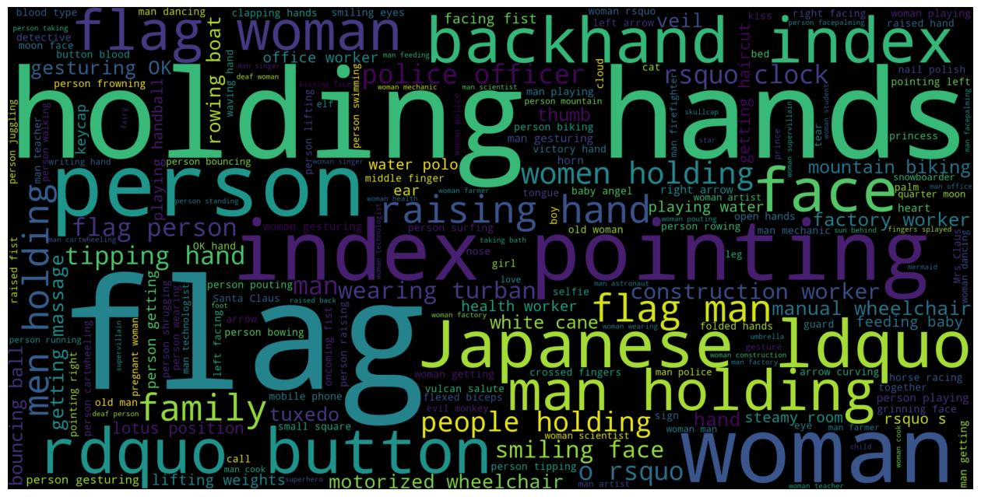

4.4.2.3 Description

The top words in description with the highest frequencies are skin tone, tone medium, light skin, dark skin, medium dark, medium skin and medium light.

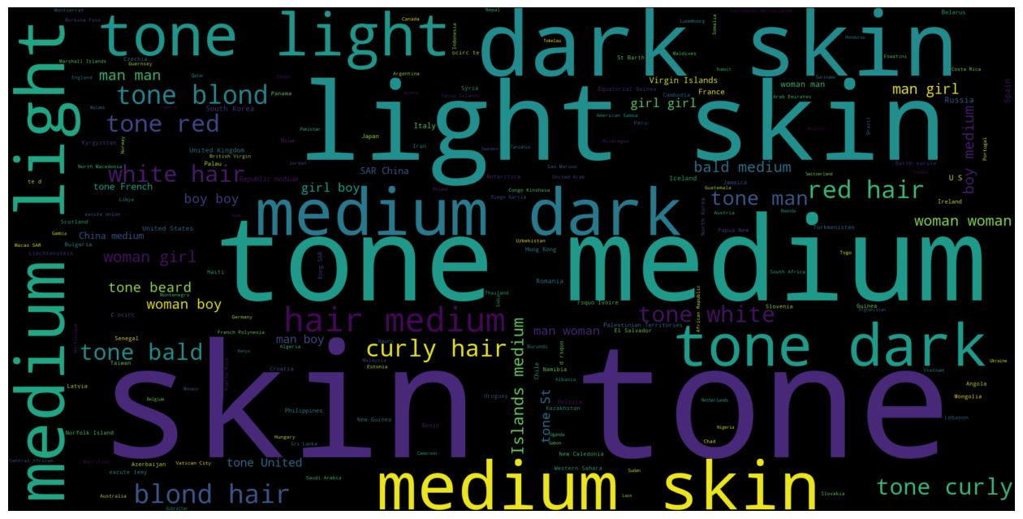

4.5 Hyperparameter

4.5.1 lr (Learning Rate):

* It controls the step size during optimization.
* Smaller values (like 0.0005) often lead to more stable training but can be slower.
* Larger values (like 0.005) can accelerate training but may risk instability.

4.5.2 noise_dim (Noise Dimension):

* It is the dimensionality of the random noise vector that is fed into the generator.
* A higher dimension can potentially generate more complex outputs.

4.5.3 projected_embed_dim (Projected Embedding Dimension):

* This hyperparameter is related to a GAN architecture where the input text vector combined with the noise vector is projected to a higher dimension.

4.5.4 batch_size:

* The number of samples processed in each training iteration.
* Larger batch sizes can improve training stability but require more memory.

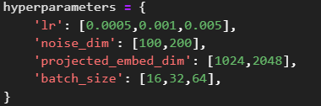

4.6 Data Visualization

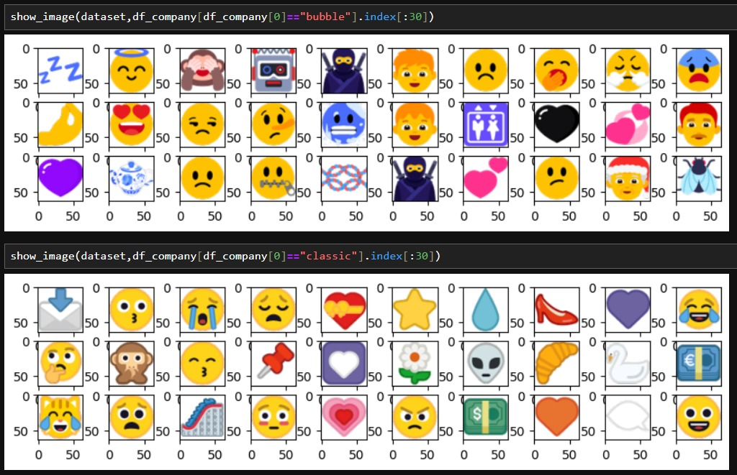

4.7 Summary

TODO

CHAPTER 5

RESULTS AND EVALUATION

5.1 Introduction

In this section the results from the experiment outlined in chapter 3 will be analysed and evaluated. The evaluation involves measuring the performance of the model based on various metrics and human evaluation.

5.3 Hyperparameter Tunning Results

Below in the figure are the different possible values for each parameter. The total number of configurations are 36 and each configuration is trained for 100 epochs.



5.3.2 Key Observations

* A learning rate of 0.0005 seems to consistently produce better results than higher learning rates, indicating that smaller steps might be more effective in this case.
* Increasing the noise dimensions generally leads to improved results, suggesting that richer representations are beneficial.
* While there's some variation, larger batch sizes tend to perform slightly better than smaller ones, possibly due to increased stability during training.

Based on the analysis, the following hyperparameter settings might be considered as a starting point:

* **lr:** 0.0005
* **noise_di:** 200
* **proj_embd_di:** 2048
* **batch_size:** 64 or more (depending on computational resources)

5.3.1 Results

|  |  |  |  |  |  |  |  |  |
| --- | --- | --- | --- | --- | --- | --- | --- | --- |
| name | lr | noise dim | Proj_embd dim | Batch  size | Fretchet dist | Inception score | Std score | Ssim score |
| Result1 | 0.0005 | 100 | 1024 | 16 | 1749.00 | 1.58 | 0.15 | 0.11 |
| Result2 | 0.0005 | 100 | 1024 | 32 | 1522.52 | 1.55 | 0.18 | 0.15 |
| Result3 | 0.0005 | 100 | 1024 | 64 | 1369.27 | 1.46 | 0.15 | 0.11 |
| Result4 | 0.0005 | 100 | 2048 | 16 | 1564.74 | 1.45 | 0.14 | 0.16 |
| Result5 | 0.0005 | 100 | 2048 | 32 | 1436.37 | 1.58 | 0.15 | 0.11 |
| Result6 | 0.0005 | 100 | 2048 | 64 | 1408.64 | 1.51 | 0.15 | 0.12 |
| Result7 | 0.0005 | 200 | 1024 | 16 | 1634.96 | 1.41 | 0.24 | 0.14 |
| Result8 | 0.0005 | 200 | 1024 | 32 | 1474.93 | 1.53 | 0.15 | 0.13 |
| Result9 | 0.0005 | 200 | 1024 | 64 | 1338.74 | 1.48 | 0.17 | 0.14 |
| Result10 | 0.0005 | 200 | 2048 | 16 | 1621.00 | 1.52 | 0.09 | 0.11 |
| Result11 | 0.0005 | 200 | 2048 | 32 | 1406.58 | 1.53 | 0.15 | 0.14 |
| Result12 | 0.0005 | 200 | 2048 | 64 | 1254.15 | 1.44 | 0.14 | 0.13 |
| Result13 | 0.001 | 100 | 1024 | 16 | 1701.52 | 1.50 | 0.18 | 0.15 |
| Result14 | 0.001 | 100 | 1024 | 32 | 1464.06 | 1.59 | 0.13 | 0.13 |
| Result15 | 0.001 | 100 | 1024 | 64 | 1342.28 | 1.42 | 0.13 | 0.13 |
| Result16 | 0.001 | 100 | 2048 | 16 | 1612.73 | 1.43 | 0.14 | 0.14 |
| Result17 | 0.001 | 100 | 2048 | 32 | 1326.29 | 1.43 | 0.13 | 0.12 |
| Result18 | 0.001 | 100 | 2048 | 64 | 1277.16 | 1.43 | 0.14 | 0.13 |
| Result19 | 0.001 | 200 | 1024 | 16 | 1543.70 | 1.47 | 0.22 | 0.15 |
| Result20 | 0.001 | 200 | 1024 | 32 | 1521.37 | 1.52 | 0.18 | 0.13 |
| Result21 | 0.001 | 200 | 1024 | 64 | 1343.98 | 1.53 | 0.19 | 0.13 |
| Result22 | 0.001 | 200 | 2048 | 16 | 1678.64 | 1.43 | 0.10 | 0.17 |
| Result23 | 0.001 | 200 | 2048 | 32 | 1419.68 | 1.53 | 0.17 | 0.15 |
| Result24 | 0.001 | 200 | 2048 | 64 | 1318.94 | 1.42 | 0.13 | 0.15 |
| Result25 | 0.005 | 100 | 1024 | 16 | 1457.36 | 1.52 | 0.13 | 0.09 |
| Result26 | 0.005 | 100 | 1024 | 32 | 1460.39 | 1.53 | 0.17 | 0.12 |
| Result27 | 0.005 | 100 | 1024 | 64 | 1366.39 | 1.49 | 0.18 | 0.13 |
| Result28 | 0.005 | 100 | 2048 | 16 | 1499.43 | 1.53 | 0.20 | 0.12 |
| Result29 | 0.005 | 100 | 2048 | 32 | 1599.96 | 1.60 | 0.21 | 0.12 |
| Result30 | 0.005 | 100 | 2048 | 64 | 1319.99 | 1.54 | 0.19 | 0.14 |
| Result31 | 0.005 | 200 | 1024 | 16 | 1649.25 | 1.44 | 0.07 | 0.10 |
| Result32 | 0.005 | 200 | 1024 | 32 | 1414.05 | 1.44 | 0.21 | 0.17 |
| Result33 | 0.005 | 200 | 1024 | 64 | 1261.21 | 1.46 | 0.19 | 0.15 |
| Result34 | 0.005 | 200 | 2048 | 16 | 1585.14 | 1.42 | 0.17 | 0.18 |
| Result35 | 0.005 | 200 | 2048 | 32 | 1353.95 | 1.53 | 0.20 | 0.16 |
| Result36 | 0.005 | 200 | 2048 | 64 | 1386.69 | 1.48 | 0.15 | 0.12 |

5.3.3 Result 12 Evaluation Metric Analysis

Below are the different evaluation metric graph where are the values for each metric is captured after every 10 epochs. Hence 1 epoch in figure represents 10 epochs.

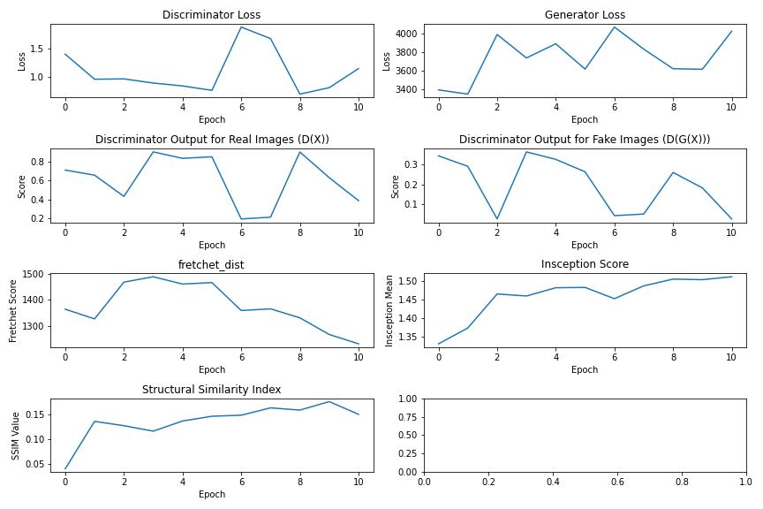

Key Observations:

* The discriminator loss is decreasing, suggesting that the discriminator is improving.
* The generator loss also is decreasing, indicating that the generator is generating more realistic images.
* The discriminator output for real images is generally close to 1, and the output for fake images is generally close to 0, suggesting that the discriminator is performing well.
* The FID is after the 20th epoch starts decreasing, suggesting that the model is improving.
* The IS is increasing, suggesting that the model is improving.
* The SSIM metric is increasing, suggesting that the generated images are becoming more structurally similar to the real images.

5.3.4 Result 12 Generated Emojis for Test Set

|  |  |
| --- | --- |
| **Real Emojis** | **Generated Emojis** |
|  |  |
|  |  |
|  |  |

5.4 Word Encoding vs Vector Embedding

|  |  |  |
| --- | --- | --- |
| **Feature** | **Word Encoding** | **Vector Embedding** |
| Representation | Discrete (integer or one-hot) | Continuous (real-valued vector) |
| Semantic Relationships | Does not capture | Captures |
| Dimensionality | High-dimensional (equal to vocabulary size) | Lower-dimensional (typically chosen based on application) |
| Out-of-Vocabulary Words | Handles poorly | Can handle through subword units |

5.5 Results Analysis for different Vector Embedding Dimension

TODO

5.8 Results Analysis for Different Learning Rate

The relationship between these metrics and the learning rate is as follows:

* **FID:** The liner trend line shows that as the learning rate increases, the fretchet distance increases, indicating degraded image quality. We can conclude that a **lower** learning rate generates better image quality.
* **IS:** Similar to FID, the linear trend line shows that as the learning rate increases, the inception score increases indicating degraded image quality. We can conclude that a **lower** learning rate generates better image quality.
* **SSIM:** The linear trend line shows that as the learning rate increases, the SSIM score decreases, indicating degraded image quality. We can conclude that a **lower** learning rate generates better image quality.

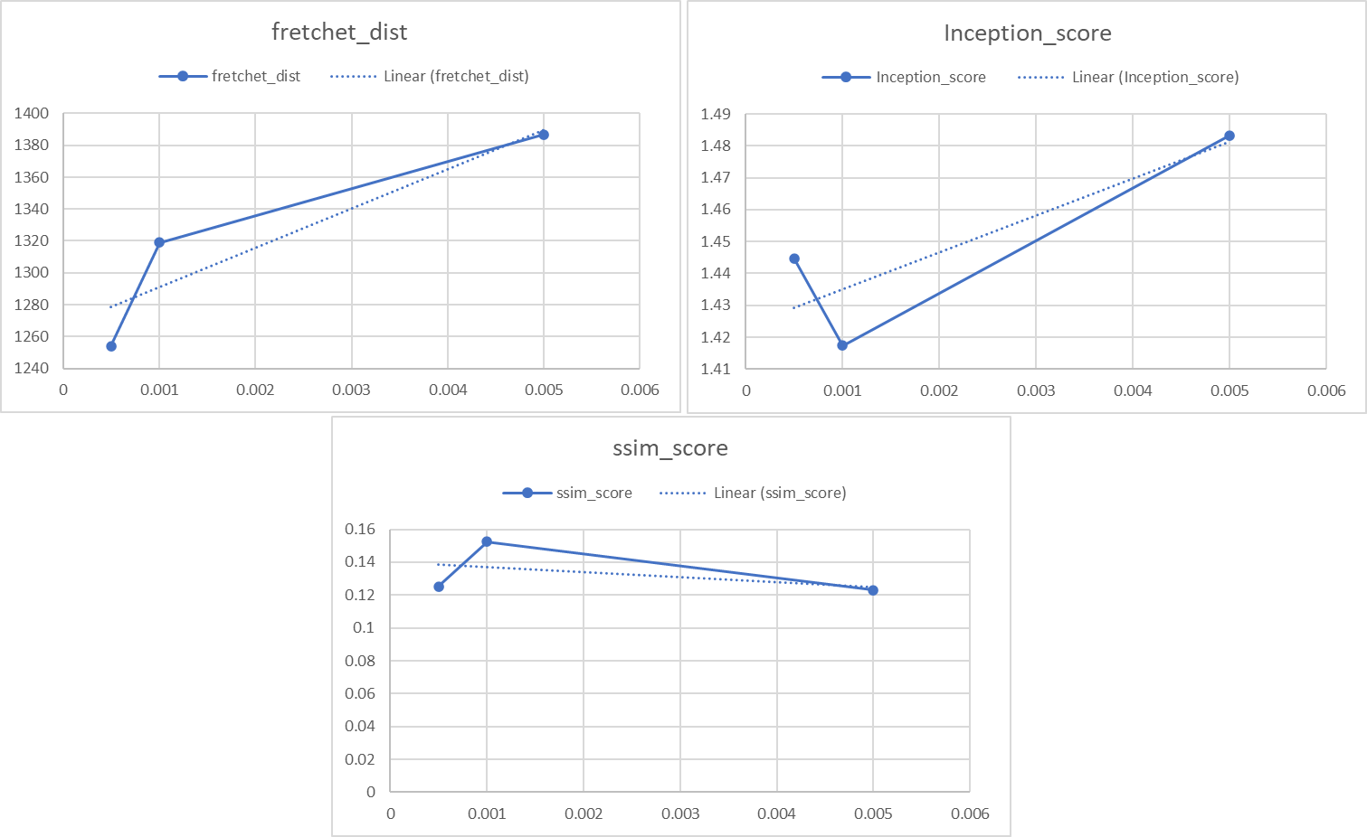

5.8 Results Analysis for Different Noise Dimensions

The relationship between these metrics and the noise dimension is as follows:

* **FID:** The liner trend line shows that as the noise dimension increases, the fretchet distance decreases, indicating elevated image quality. We can conclude that a **higher** noise dimension generates better image quality.
* **IS:** Similar to FID, the linear trend line shows that as the noise dimension increases, the inception score decreases, indicating elevated image quality. We can conclude that a **higher** noise dimension generates better image quality.
* **SSIM:** The linear trend line shows that as noise dimension decreases, the SSIM score decreases, indicating elevated image quality. We can conclude that a **higher** noise dimension generates better image quality.

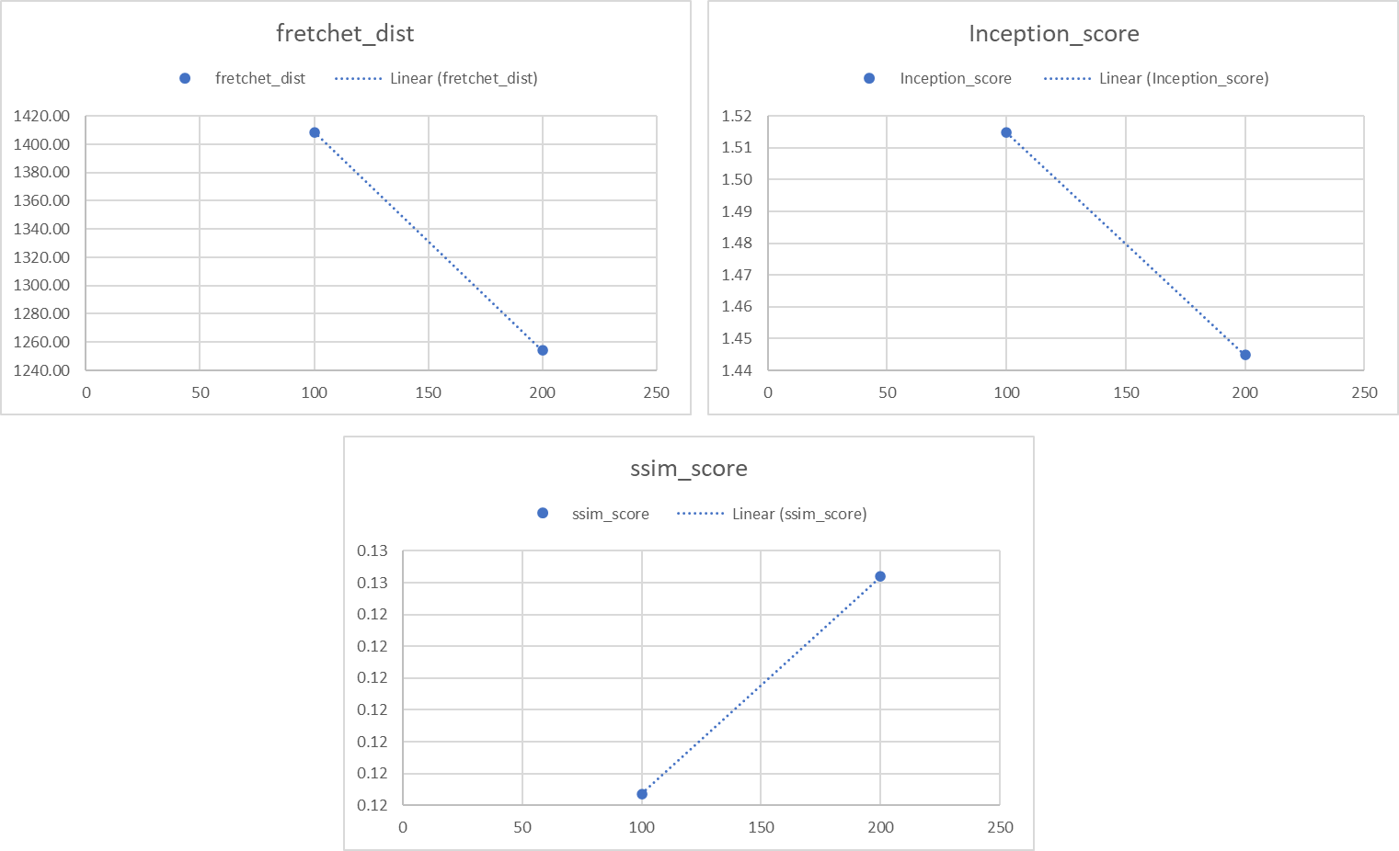

5.8 Results Analysis for Different Projected Embedding

The relationship between these metrics and the projected embedding dimension is as follows:

* **FID:** The liner trend line shows that as the projected embedding dimension increases, the fretchet distance decreases, indicating elevated image quality. We can conclude that a **higher** projected embedding dimension generates better image quality.
* **IS:** Similar to FID, the linear trend line shows that as the projected embedding dimension increases, the inception score decreases, indicating elevated image quality. We can conclude that a **higher** projected embedding dimension generates better image quality.
* **SSIM:** The linear trend line shows that as projected embedding dimension increases, the SSIM score decreases, indicating degraded image quality. We can conclude that a **lower** projected embedding dimension generates better image quality.

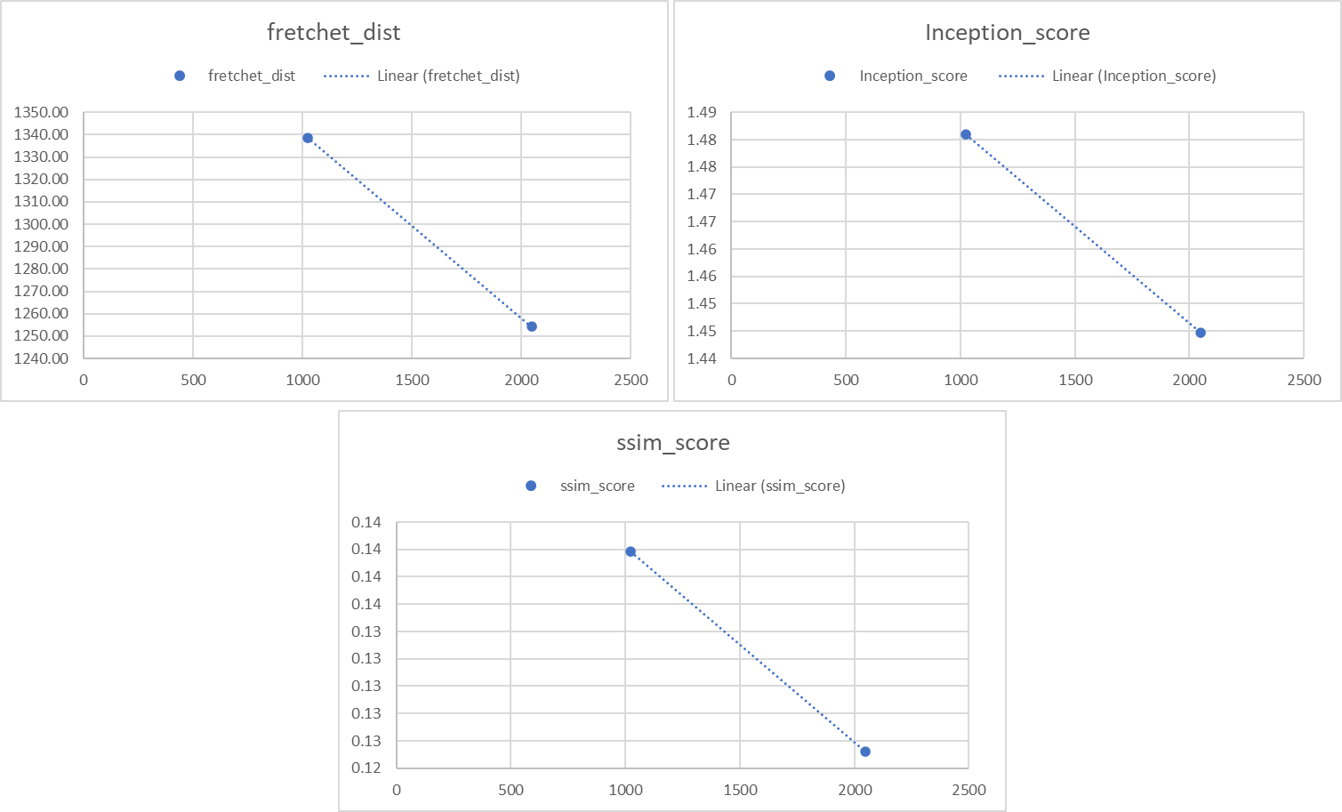

5.8 Results Analysis for Different Batch Size

The relationship between these metrics and the batch size is as follows:

* **FID:** The liner trend line shows that as the batch size increases, the fretchet distance decreases, indicating elevated image quality. We can conclude that a **higher** batch size generates better image quality.
* **IS:** Similar to FID, the linear trend line shows that as batch size increases, the inception score decreases significantly, indicating elevated image quality. We can conclude that a **higher** batch size generates better image quality.
* **SSIM:** The linear trend line shows that as batch size increases, the SSIM score decreases slightly, indicating improved image quality. We can conclude that a **higher** batch size generates better image quality.

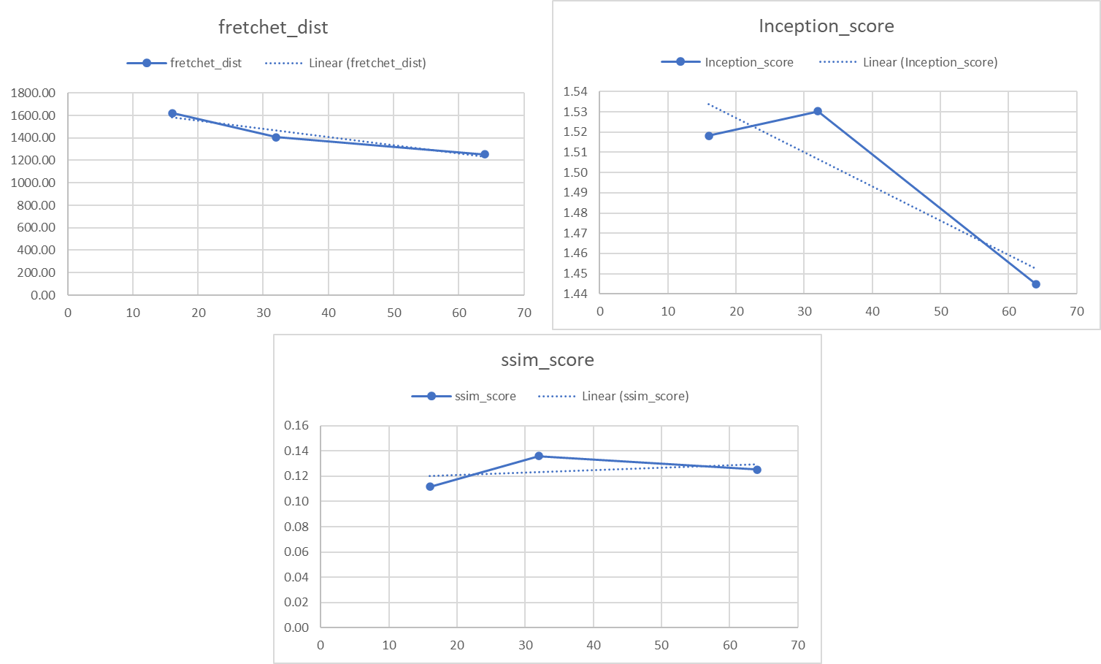

5.6 Stage I Generator Output for the best Hyperparameter

5.6.1 Qualitative Evaluation

* Epoch 1  
  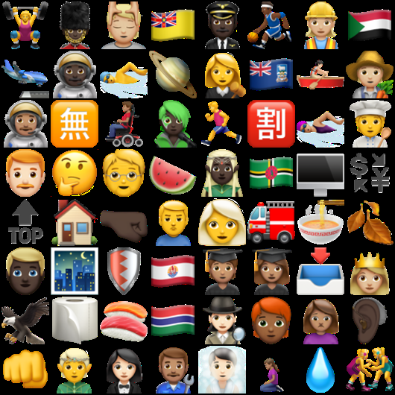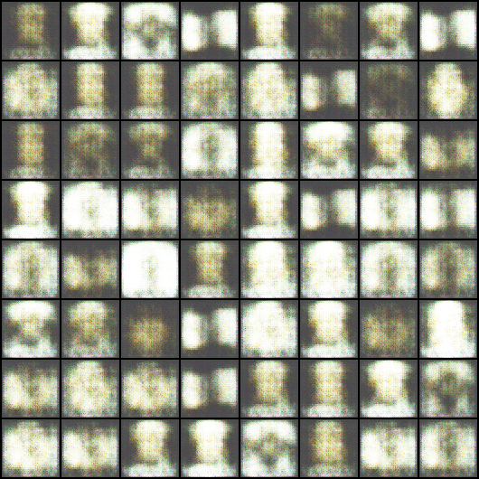
* Epoch 150  
  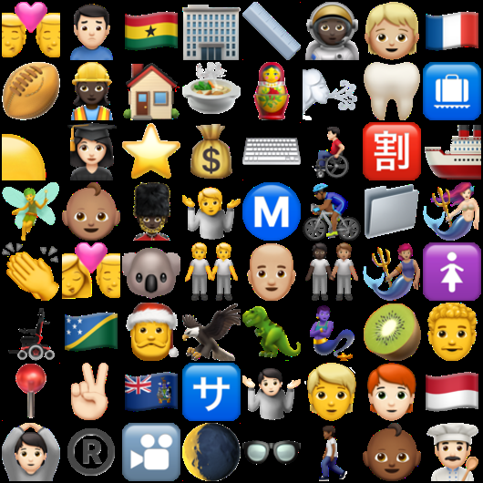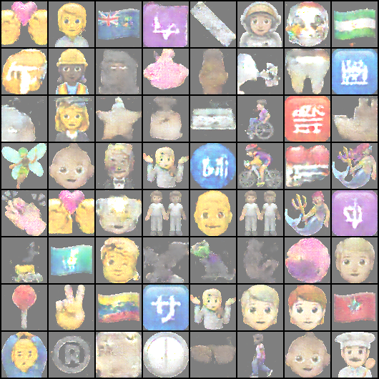
* Epoch 300  
  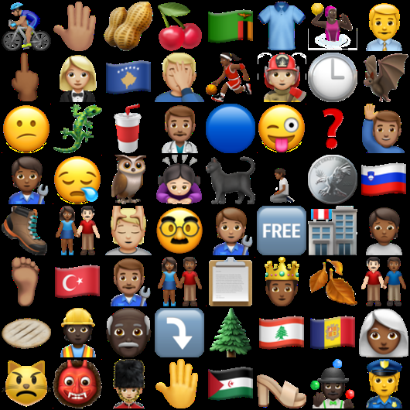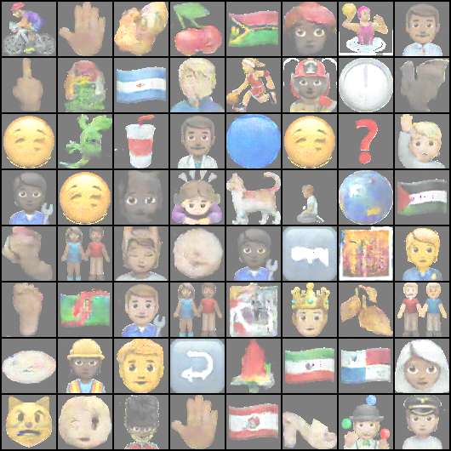
* Epoch 450  
  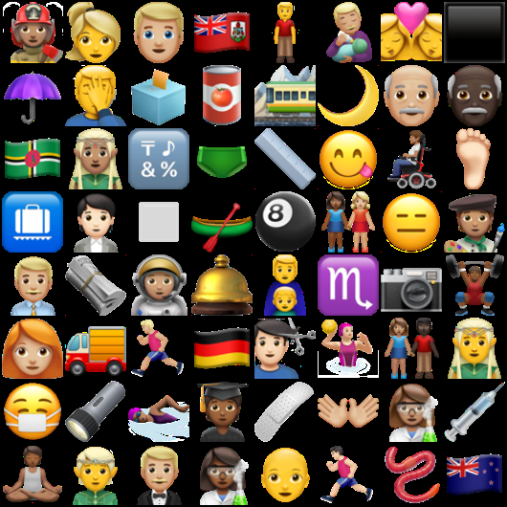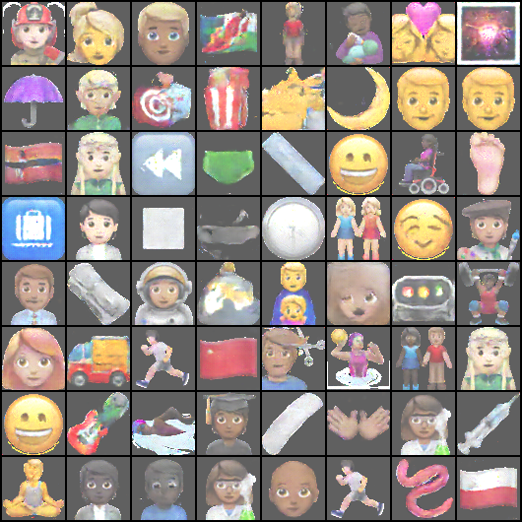
* Epoch 600  
  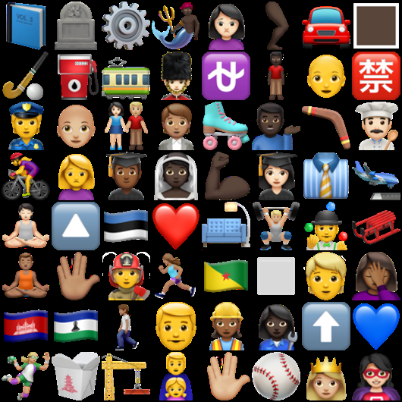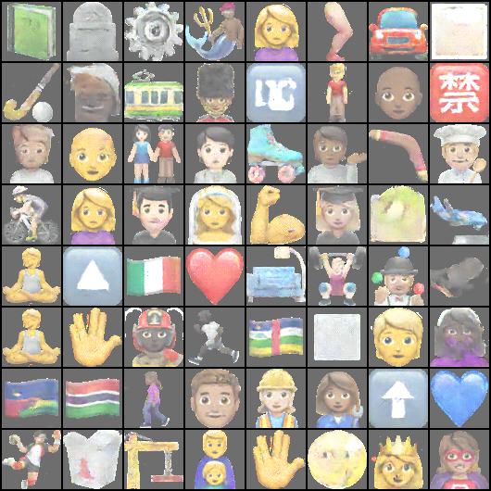
* Epoch 750  
  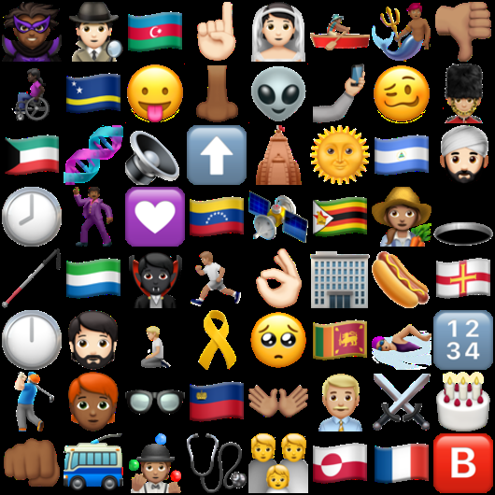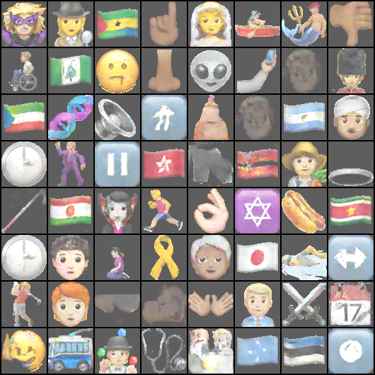
* Epoch 900  
  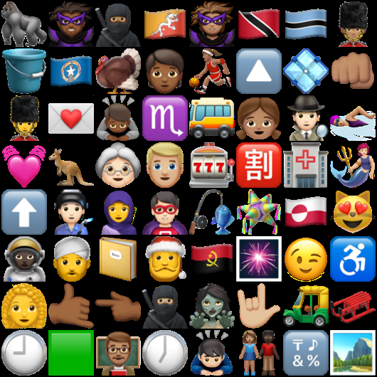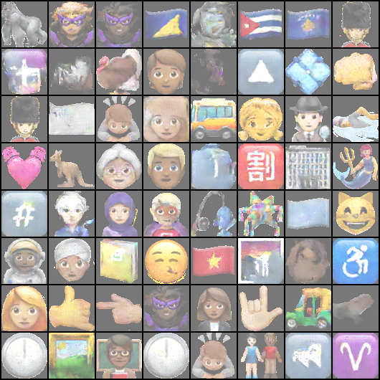
* Epoch 1000  
  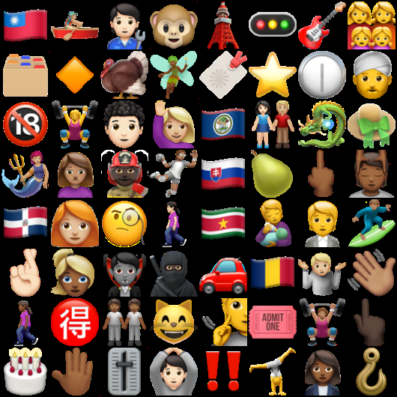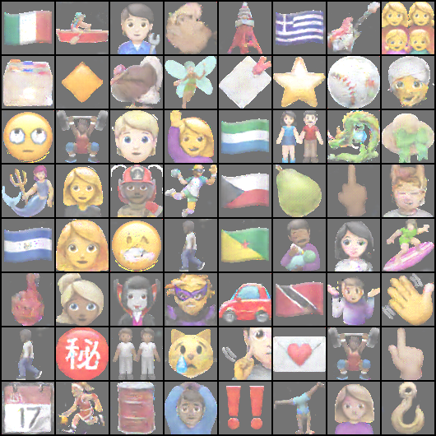
* Test Data

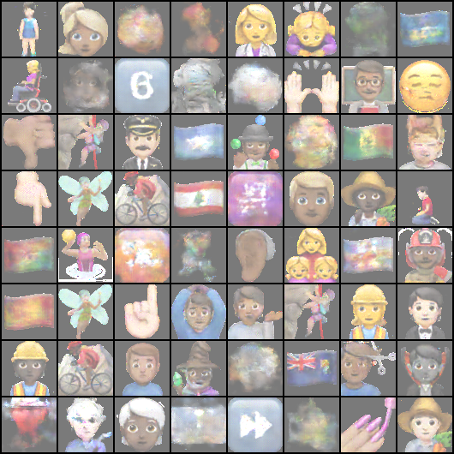

* + 1. Stage I Generated Images Observation
* The generated images exhibit a variety of subjects, facial expressions, and backgrounds. GAN has learned to capture some of the underlying patterns and variations in the training data.
* The GAN struggles to generate flag, face emojis and textual emojis.
* The GAN is able to human figures and faces with different action-like hair cutting, praying cycling with the mountain in the background.

5.6.2 Quantitative Evaluation

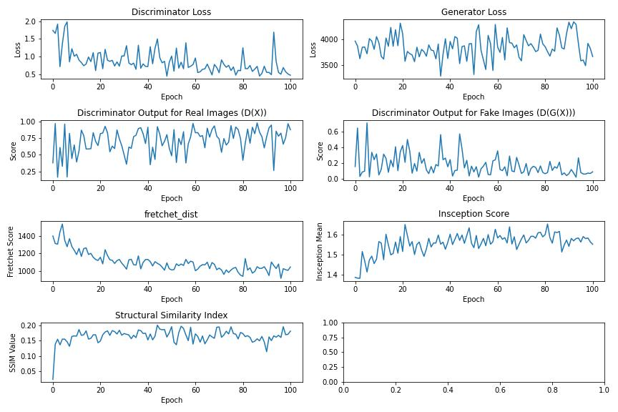

Key Observations:

* The discriminator loss is decreasing, suggesting that the discriminator is improving.
* The generator loss also is decreasing, indicating that the generator is generating more realistic images.
* The discriminator output for real images is generally close to 1, and the output for fake images is generally close to 0, suggesting that the discriminator is performing well.
* The FID is decreasing, suggesting that the model is improving.
* The IS is increasing, suggesting that the model is improving.
* The SSIM metric is increasing and after 400 epoch it flattens out, suggesting that the generated images are becoming more structurally similar to the real images.

Stage I Test Set Results

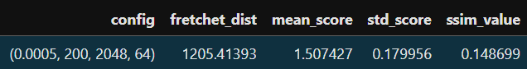

5.7 Stage II Generator Output for the best Hyperparameter

* + 1. Qualitative Evaluation
* Epoch 1  
  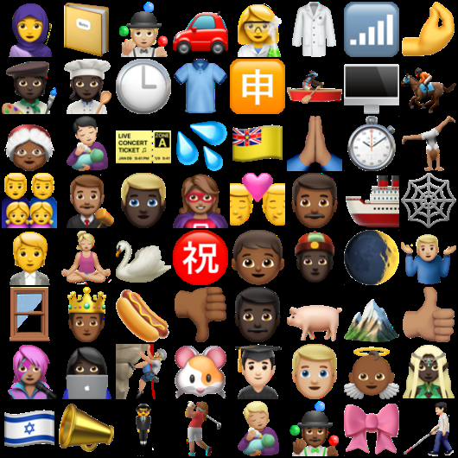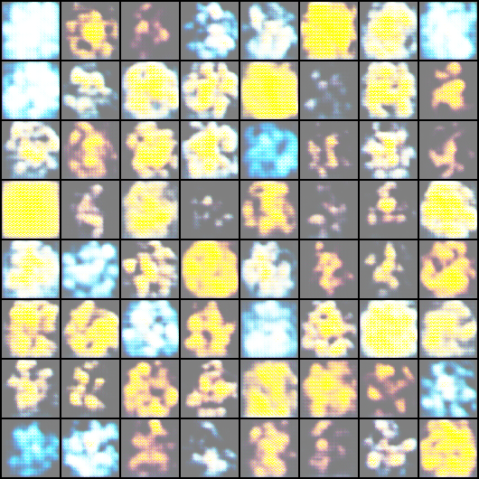
* Epoch 100  
  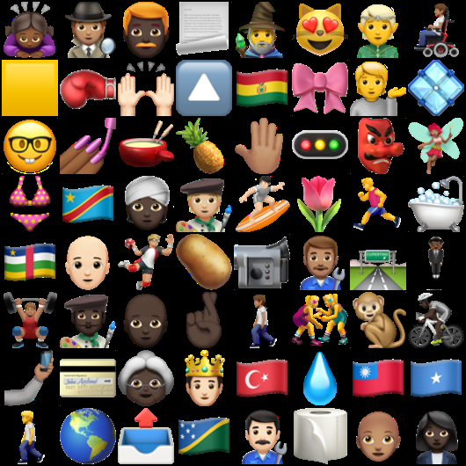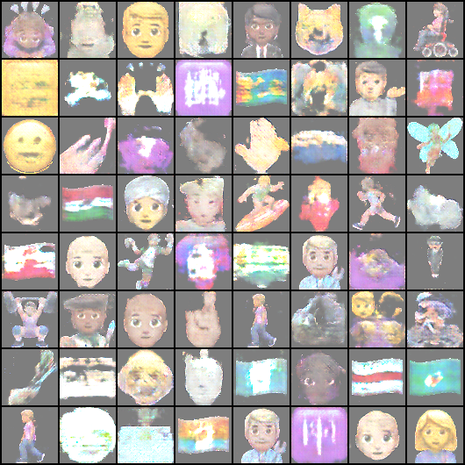
* Epoch 200  
  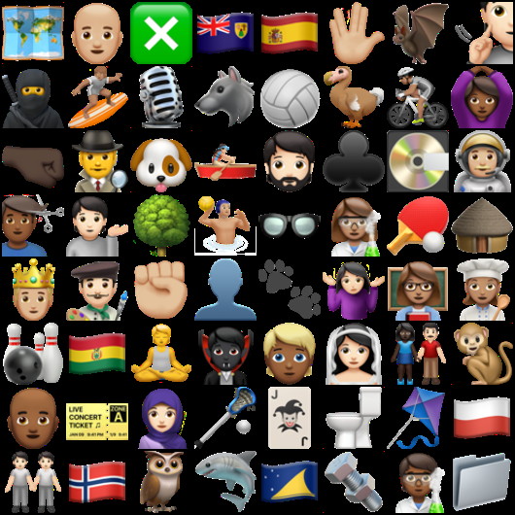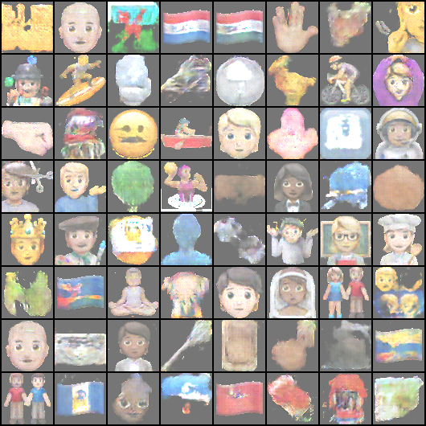
* Epoch 300  
  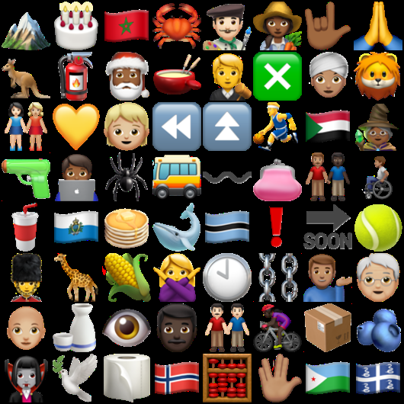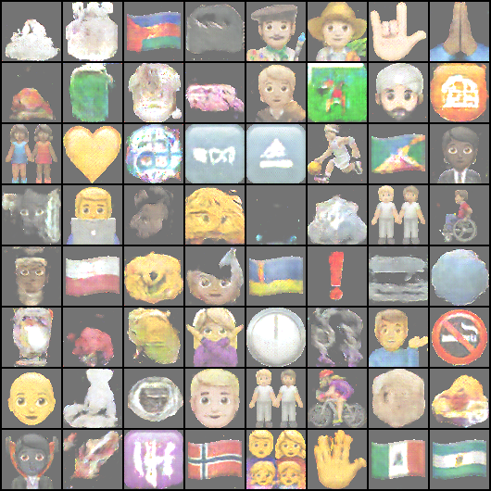
* Epoch 400

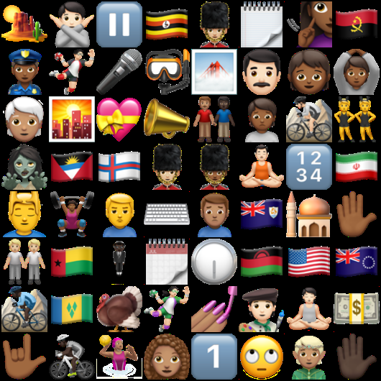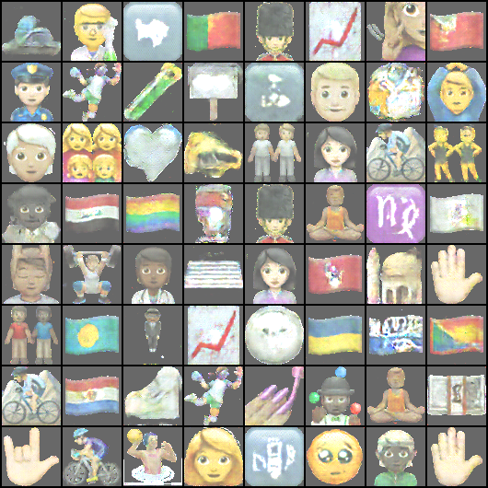

* Epoch 500  
  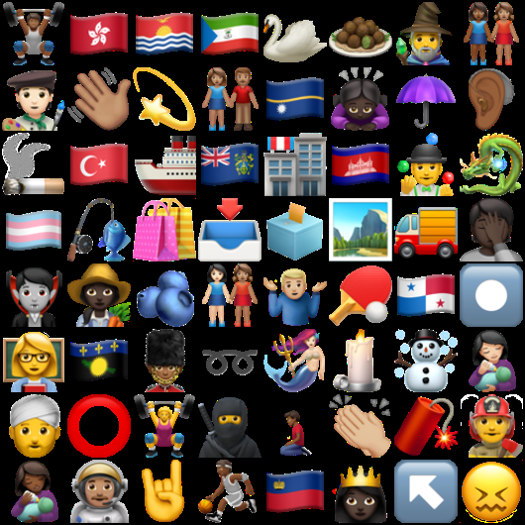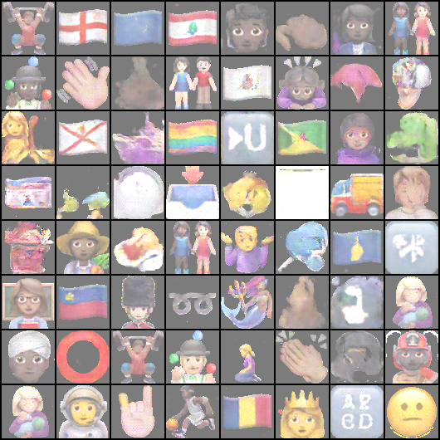
* Test

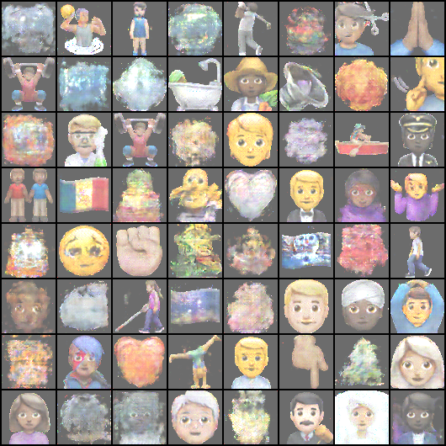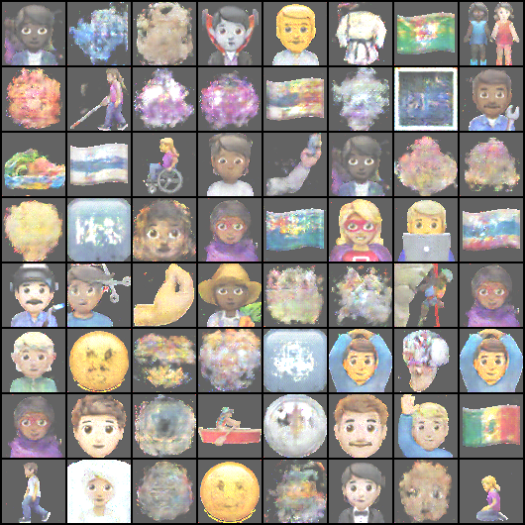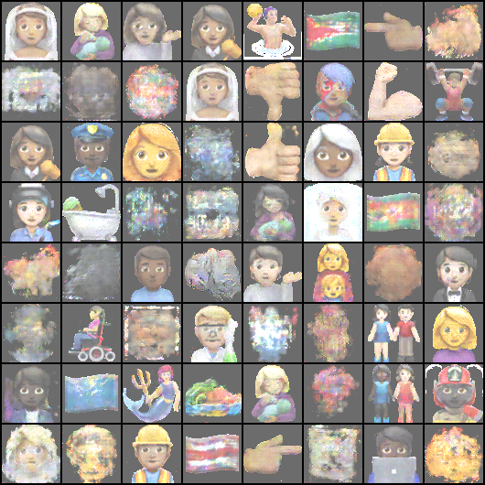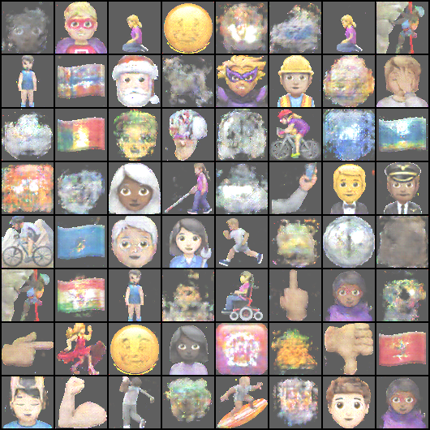

* + 1. Stage II Generated Images Observation
* We can see that the State II Generator visually performs better that the Stage I Generator results.
* Some emojis, especially human figures and faces, are more recognizable but slightly distorted. This is common in GANs when the network is trained on a diverse dataset but hasn't fully learned fine details.
* Background elements like cosmic or cloudy patterns.
* Many human-like emojis like people biking, walking, wearing helmets show that the GAN is trying to capture movement and diverse activities,
* The results while imperfect indicate a good generalize across these categories.

5.7.2 Quantitative Evaluation

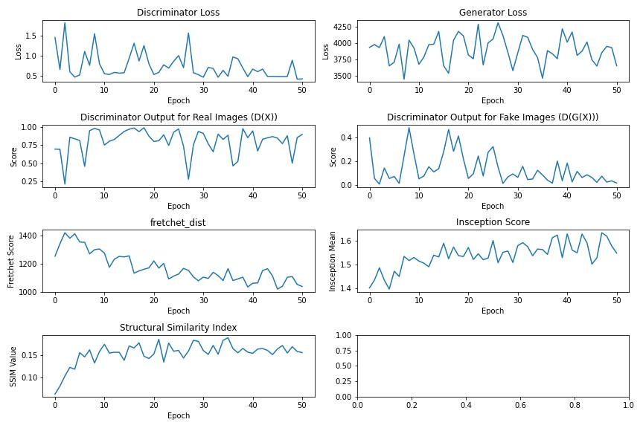

Key Observations:

* The discriminator loss is decreasing, suggesting that the discriminator is improving.
* The generator loss also is decreasing, indicating that the generator is generating more realistic images.
* The discriminator output for real images is generally close to 1, and the output for fake images is generally close to 0, suggesting that the discriminator is performing well.
* The FID is decreasing, suggesting that the model is improving.
* The IS is increasing, suggesting that the model is improving.
* The SSIM metric is increasing and after 400 epoch it flattens out, suggesting that the generated images are becoming more structurally similar to the real images.

Stage II Test Set Results

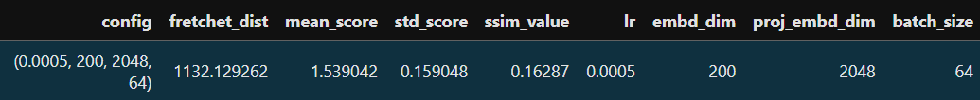

5.8 Comparison between metrics

* **FID:** Best suited for comparing the overall distribution of generated images to real images. It's sensitive to differences in the statistical properties of the images.
* **IS:** Ideal for evaluating the diversity and quality of generated images. It's particularly useful when you want to ensure that the model is generating a wide variety of realistic images.
* **SSIM:** Excellent for measuring the perceptual similarity between two images. It's suitable when you want to assess how similar the generated images look to the real ones in terms of their visual structure.

In summary, FID is often used for comparing the overall quality of generated images, IS evaluates the diversity and quality, and SSIM focuses on perceptual similarity. The best metric to use depends on your specific goals and the characteristics of your dataset. It's often beneficial to combine these metrics for a more comprehensive evaluation.

CHAPTER 6

CONCLUSIONS AND RECOMMENDATIONS

6.1 Introduction

This chapter summarizes the key findings of this research and offers recommendations for future work.The study's primary goal was to enhance Generative Adversarial Networks' (GANs') performance on an emoji dataset by tackling issues with image quality, diversity, and evaluation metrics. This study has shed light on the shortcomings and prospects for future advancements in emoji generation through the examination of several GAN designs and training methods.

The study's conclusions demonstrate the advancements made in strengthening GANs capacity for producing precise and small-scale images. Despite these developments a number of drawbacks were found related to resource limitations, training scalability and image resolution. In order to get around these restrictions and expand on the research described in this chapter also includes important suggestions that other researchers should consider.

6.2 Discussion and Conclusion

This thesis has successfully demonstrated the feasibility of generating high quality emojis using Stacked Generative Adversarial Networks (GANs). The proposed Stacked GAN architecture, combined with careful hyperparameter tuning, outperformed the baseline Stage I GAN model in terms of image quality and diversity.

The evaluation metrics employed in this study, FID, IS, and SSIM, provided valuable insights into the performance of both models. The Stacked GAN consistently achieved lower FID and higher IS scores, indicating a more diverse and higher-quality output. Additionally, the SSIM values demonstrated that the Stacked GAN generated images with better structural similarity to real emojis.

The performance of the Stacked GAN can be attributed to its growth mechanism and hierarchical feature learning. By starting with low-resolution images and gradually increasing the resolution, the Stacked GAN can effectively learn and capture complex patterns in the data. Furthermore, the hierarchical structure allows the model to focus on different levels of detail, leading to more realistic and expressive emojis.

Hyperparameter tuning played a critical role in optimizing the performance of both models. By carefully selecting appropriate values for parameters like learning rate, projected embedding dimension, noise dimension and batch size the model was able to perform better.

While the Stacked GAN demonstrated significant advantages in this study, there are still areas for future exploration. For instance, incorporating conditional GANs could enable more targeted and controlled emoji generation based on specific attributes or styles. Additionally, exploring alternative loss functions or regularization techniques might further enhance the performance of the model.

In conclusion, this thesis has made a valuable contribution to the field of emoji generation by demonstrating the effectiveness of Stacked GANs. The findings of this research can be applied to various applications, such as social media platforms, messaging apps, and virtual reality experiences.

6.3 Contribution to Knowledge

* This research significantly contributes to the enhancement of GAN (Generative Adversarial Network) performance specifically when applied to an emoji dataset. Through innovative methods for training, architecture optimization, or data augmentation, the study enhances GANs' capacity to produce emoji images that are diverse, high-quality, and suitable for their context. Along with handling limited variation and complex visual details in small-sized images, the work also entails a detailed analysis of the particular challenges posed by the emoji dataset and making sure the generated emojis maintain their visual recognition while showcasing creative diversity. Therefore, the results of this study provide important information about how to enhance GAN models for other image generation tasks that require small, intricate, and meaningful datasets.
* This research significantly contributes to the comparative analysis of various evaluation metrics on an emoji dataset. The study provides a deeper understanding of the efficacy of various evaluation techniques in evaluating the quality and diversity of emoji images produced by models such as GANs by methodically analyzing and contrasting their advantages and disadvantages. These evaluation techniques include the Inception Score (IS), Fréchet Inception Distance (FID) and Structural Similarity Index (SSIM). The study examines how various metrics capture various features of the emoji dataset, including visual fidelity, diversity, and user-perceived quality, in addition to highlighting the disparities between them. Since most emojis are small, driven by symbols, and have contextual meaning, this study makes a unique contribution by suggesting or improving evaluation criteria that better fit the features of these kinds of datasets.
* This research significantly contributes to the comparative analysis of standard GAN (Generative Adversarial Network) architectures with Stacked GAN models when applied to the emoji dataset. The study investigates the variations in performance, image quality, and emoji diversity produced by methodically assessing both models. In comparison to a single-stage GAN, the research demonstrates how Stacked GAN, which consists of multiple layers or stages of GANs, may enhance image generation by improving features at each stage and generating more detailed and contextually relevant emojis. The paper explores the unique benefits that Stacked GANs provide for managing the fine details in emoji creation, including better color schemes, higher consistency amongst emoji styles, and the ability to capture fine textures. The study also addresses the training difficulties and computational costs related to each model, offering a fair assessment of their advantages and disadvantages. The results of intensive testing help to clarify how each architecture responds to the particular difficulties presented by emoji datasets, including the requirement for a variety of expressions, small image sizes, and minimalistic designs. In the end, these insights provide useful suggestions for enhancing image generation tasks in related fields."

6.4 Future Recommendations

* Due to limited computational resources, the GAN network in this study was trained on a partial subset of the emoji dataset. The limited training data somewhat limited the diversity and variety of the generated emojis, even though the model generated some good results based on this smaller dataset. We advise using the entire dataset to train the GAN in order to improve the model's performance even more and increase the variety of emojis it can generate. By doing this, the model would be better able to produce a richer and more varied spectrum of emojis, including uncommon or complex types, by capturing a larger range of features, patterns, and variations found throughout the entire emoji set. In real-world applications, where the model is expected to generate an extensive and visually varied collection of emojis, accommodating a range of contexts and user preferences, this expanded training would be extremely beneficial. To fully realize the potential of the model and enhance its ability to produce diverse, high-quality emoji images, more resources must be made available for full dataset training.
* Raising the image resolution of the pictures produced by the Stage II Generator to 128x128 pixels is one of the main suggestions for further research. It is anticipated that increasing the resolution at this point will greatly enhance the produced images' quality, sharpness, and detail. As of right now, the model might be limited by lower-resolution outputs, which could lead to features that are less accurate or blurry, especially for complex designs or minute details, which are frequently essential in image generation tasks like making emojis. However, this enhancement will likely require more computational power and memory, as higher-resolution images demand more intensive processing. Therefore, future work should also consider optimizing the training process and exploring more efficient architectures or hardware solutions to balance the trade-off between computational cost and image quality.
* A key recommendation for future work is to perform extensive hyperparameter tuning for the Stage II Generator to optimize its performance. Hyperparameters such as the learning rate, batch size, number of training epochs, dropout rate, and the architecture’s latent space dimensionality can significantly impact the quality of the images produced, especially in a multi-stage GAN framework where Stage II is responsible for refining and enhancing the output generated in Stage I.

REFERENCES

Asudani, D.S., Nagwani, N.K. and Singh, P., (2023) Impact of word embedding models on text analytics in deep learning environment: a review. *Artificial Intelligence Review*, [online] 569, pp.10345–10425. Available at: https://doi.org/10.1007/s10462-023-10419-1.

Cavalheiro, B.P., Rodrigues, D.L. and Prada, M., (2023) Who (and with whom) uses more emoji? Exploring individual, relational, and motivational characteristics driving emoji use. *Telematics and Informatics*, [online] 83, p.102023. Available at: https://www.sciencedirect.com/science/article/pii/S0736585323000874.

Crowson, K., Biderman, S., Kornis, D., Stander, D., Hallahan, E., Castricato, L. and Raff, E., (2022) Vqgan-clip: Open domain image generation and editing with natural language guidance. In: *European Conference on Computer Vision*. Springer, pp.88–105.

Dhivya, K. and Navas, N.S., (2020) Text to realistic image generation using stackgan. In: *2020 7th International Conference on Smart Structures and Systems (ICSSS)*. IEEE, pp.1–7.

Erle, T.M., Schmid, K., Goslar, S.H. and Martin, J.D., (2022) Emojis as social information in digital communication. *Emotion*, 227, p.1529.

Kennison, S.M., Fritz, K., Morales, M.A.H. and Chan-Tin, E., (2024) Emoji use in social media posts: relationships with personality traits and word usage. *Frontiers in Psychology*, 15.

Ku, H. and Lee, M., (2023) TextControlGAN: Text-to-Image Synthesis with Controllable Generative Adversarial Networks. *Applied Sciences*, 138, p.5098.

Lee, S., Kim, S., Chu, Y., Choi, J., Park, E. and Woo, S.S., (2023) EAE-GAN: Emotion-Aware Emoji Generative Adversarial Network for Computational Modeling Diverse and Fine-Grained Human Emotions. *IEEE Transactions on Computational Social Systems*, pp.1–11.

Mittal, P., Aggarwal, K., Sahu, P.P., Vatsalya, V., Mitra, S., Singh, V., Veera, V. and Venkatesan, S.M., (2020) Photo-realistic emoticon generation using multi-modal input. In: *Proceedings of the 25th International Conference on Intelligent User Interfaces*. pp.254–258.

Patashnik, O., Wu, Z., Shechtman, E., Cohen-Or, D. and Lischinski, D., (2021) Styleclip: Text-driven manipulation of stylegan imagery. In: *Proceedings of the IEEE/CVF International Conference on Computer Vision*. pp.2085–2094.

Provine, R.R., Spencer, R.J. and Mandell, D.L., (2007) Emotional expression online: Emoticons punctuate website text messages. *Journal of language and social psychology*, 263, pp.299–307.

Sauer, A., Karras, T., Laine, S., Geiger, A. and Aila, T., (2023) Stylegan-t: Unlocking the power of gans for fast large-scale text-to-image synthesis. *arXiv preprint arXiv:2301.09515*.

Shmelkov, K., Schmid, C. and Alahari, K., (2018) How good is my GAN? In: *Proceedings of the European conference on computer vision (ECCV)*. pp.213–229.

Trevisan de Souza, V.L., Marques, B.A.D., Batagelo, H.C. and Gois, J.P., (2023) A review on Generative Adversarial Networks for image generation. *Computers & Graphics*, [online] 114, pp.13–25. Available at: https://www.sciencedirect.com/science/article/pii/S009784932300064X.

Urumutta Hewage, G.S., Liu, Y., Wang, Z. and Mao, H., (2021) Consumer responses toward symmetric versus asymmetric facial expression emojis. *Marketing Letters*, 32, pp.219–230.

Xu, T., Zhang, P., Huang, Q., Zhang, H., Gan, Z., Huang, X. and He, X., (2018) Attngan: Fine-grained text to image generation with attentional generative adversarial networks. In: *Proceedings of the IEEE conference on computer vision and pattern recognition*. pp.1316–1324.

APPENDIX A: RESEARCH PROPOSAL

emoji generation based on textual input using generative adversarial networks

DARSHIL AJAY PAREKH

Research Proposal

FEBRUARY 2024

Abstract

With the increase in popularity with its wide variety of uses, emojis have become so necessary and important that sending or responding to a message and commenting or reacting to a post on social media without emoji seems to be impossible. Emoji represents emotions, culture, age, gender, actions, gesture, expressions, sports, foods, places and objects.

Despite the importance the number of emojis are countable and finite in quantity. In this research we will be creating a generative model to generate new unique emojis using short text for more complex and distinction emojis

We will be using the state-of-the-art generative models which consist of mainly two-part generator and discriminator. The generator and discriminator will work one after the other. First the generator will be trained to generate new emojis and after couple of rounds the discriminator will be trained to detect is the emoji is fake or real. This is followed by generator and discriminator rounds. This process continues until the discriminator is not able to detect is the emoji is fake.

This will help the community to generate wide variety of emojis based on the requirement rather than choosing from a finite set of emojis.

This research will help to generate high quality and diverse emojis. It will also help the tech community with the comparison of the different GAN models with different evaluation metrics.

**TABLE OF CONTENTS**

Abstract 2

LIST OF FIGURES 4

LIST OF TABLES 5

LIST OF ABBREVIATIONS 6

1. Background 7

2.1 Problem Statement 9

2.2 Related Work 10

2.2.1 Research on Emoji and its Importance 10

2.2.3 Research on Word Embeddings: 11

3. Research Questions 13

3.1 Research Questions 13

4. Aim and Objectives 13

5. Significance of the Study 14

5.1 Contributions 14

5.2 Beneficiaries 14

6. Scope of the Study 14

7. Research Methodology 15

7.1 Introduction 15

7.2 Dataset description 15

7.3 Data preprocessing 16

7.4 Transformation 16

7.5 Models 16

7.6 High Level Flow Diagram 17

7.7 Evaluation metrics 17

8. Requirements or Resources 18

8.1 Hardware Requirement 18

8.2 Software, Web Services and Libraries Requirement 18

9. Research Plan 19

LIST OF FIGURES

Figure 1 Sample emojis used frequently in informal communication. 7

Figure 2 Emoji used in a feedback form 8

Figure 3 Dataset sample 15

Figure 4 High Level Flow Diagram 17

Figure 5 Research Plan 19

LIST OF TABLES

Table 1 Related works on Methodologies 12

Table 2 State-of-the-art model to be used for emoji generation 17

LIST OF ABBREVIATIONS

GAN Generative Adversarial Network

VQGAN Vector Quantized Generative Adversarial Network

DCGAN Deep Convolution Generative Adversarial Network

CLIP Contrastive Language-Image Pre-Training

AI Artificial Intelligence

ML Machine Learning

RGB Red Green Blue

RGBA Red Green Blue Alpha

1. Background

Emoji is a visual representation of human interaction based on Human emotions, living beings, objects and symbols. These are in widespread use across the internet such as in textual messaging application, social media platforms which are known as informal modes of communication. Below is an image about the most frequently used emojis during informal modes of communication.



Figure *8* Sample emojis used frequently in informal communication.

According to (Kennison et al., 2024) emojis represent faces with human expressions, objects, animals, and actions.

Emojis are often used to in replacement of words, thus acting as a part of communication and language (Provine et al., 2007). As per the research (Urumutta Hewage et al., 2021) the emojis are static images which are often preserved as human like emotion and expressions. Further, as per (Erle et al., 2022) the communication has greater emotional intensity when we communicated to people using emojis rather than without emojis.

Other application of emojis other than informal communication includes

* Rating/Feedback Form : The feedback forms using emoji instead of stars or numbers. The research has found that the chances of the user giving feedback is higher when emojis are used.
* Providing a Reaction : These days most online applications or websites provide emojis to react to a post, blog, article or tweet.
  + Thumbs up and down emojis are used to like and dislike.
  + Facial emojis are used to express feeling like surprise, wow or shocked.



Figure *9* Emoji used in a feedback form

As per the emojipedia.org analysis of over 2.934 billion global tweets between 2017 to 2021, the percentage of tweets with at least one emoji has increased from 13.5% to 21.5%. With the increase of the use of emoji, the demand for newer and customised emoji is increasing. The creation of emoji is a currently is a tedious process of submitting an emoji to Unicode Technical Committee, which takes the final decision for the inclusion, this takes 18-24 months for the complete process Using the state-of-the-art models for generating images using text, we will be able to create new emojis based on the user input.

Prior research has focused on generating facial emojis and emotion based facial emojis. With the state-of-the-art model and architecture, we will be generating not only facial emojis but objects also.

Prior research used techniques like unsupervised learning , Deep Convolution based Generative Adversarial Networks and Conditional Generative Adversarial Networks.

One of the greatest debates on emojis includes whether emoji can be used “as punctuation” or ”after punctuation” which was included in “The Great Emoji Debate”.

In this research we will be creating a state-of-the-art model to generate emojis using emoji content and descriptive information of the emoji and comparing the model with prior models.

We will be looking at the various generative adversarial models :

* VQGAN-CLIP
* TextControl-GAN
* StyleGAN-T

**2. Problem Statement and Related Work**

2.1 Problem Statement

Currently the process of creating new emojis is a tedious and time-consuming task which takes a couple of days or months to create and years to get approval from the Unicode Technical Committee. Currently there are only 3,664 emojis as per Unicode standard and the need for need and diverse emoji is increasing. Due to this the current library faces limitations in capturing all the human emotion and experiences. This can lead to miscommunication and inadequate representation of culture and identities.

As per the current trend the use of emoji has been steadily increasing in informal conversation and social media. The need for new emojis to be generated quickly based on the text from the user is high. This issue mostly affects the Gen Z generation as they are the ones who use them mostly during the social media platforms, Messaging apps and content creation. It is important as it can improve the quality of the conversation with improved emotions and objects. This solution will have a huge impact on the conversation by improving the quality of the conversation with new and better emojis which can express emotions and objects accurately.

2.2 Related Work

2.2.1 Research on Emoji and its Importance

Emoji despite being more common in digital communication, is often dependent on characteristics, motives for using them and the context in which they are used (Cavalheiro et al., 2023). Over the past couple of years there has been extensive research in the use and importance of emojis in every life activity. Below are few of the recent research with description and findings:

* The research by (Cavalheiro et al., 2023) try to find the relationship of frequency of the emoji with relationship and individual characteristics. The research also found personal reasons to be one of the relates to high emoji frequency. The research also found age to be directly correlated with emoji frequency which was unexpected.
* The research by (Erle et al., 2022) discusses a creation of emojis in digital communication with the help of their model. The research also found that the emojis can depict the facial expression of the human.
* The research by (Lefebvre et al., 2024) is about the influence of emoji during tip suggestion with the tipping percentage. The research also found significant positive effects of emoji during the tipping.
* The research by (Kennison et al., 2024) relates the personal characteristics with the emojis used in the conversation. The research also found that the men used emojis less often than women. The research also found that users may me using emojis in place of word and used less dictionary words.

**2.2.2 Research on Emoji Generation**

With the evolution generative models and the importance of emoji there has been couple of research done in the field of emoji generation. It has been noticed that most of the research has been around facial emojis and with a very limited set of them. Below are few of the recent research with description:

* The research (Mittal et al., 2020) uses supervised learning with multimodal input to GAN with U-Net like architecture for the generator to generate realistic hand drawn emojis. This research even though was able to generate the emojis it required the user to draw a rough sketch with the emotion to be given as input, also the dataset used had to be augmented from the facial emojis which don’t depict the real dataset.
* The research (Lee et al., 2023) creates a model which can generate emojis based on emotional degree for more complex and detailed usage on online conversations (Lee et al., 2023). The research uses conditional GAN for the experiment and also compares it with other baseline models. This
* The research (Tang, 2023) used unsupervised learning to generate new emojis using DCGAN which is a combination of Convolution Neural Network and Generative Adversarial Network. This research faced many challenges like after 1000 epochs the accuracy flattens out. The emojis generated where quite blurry and the user had no control over the emojis generated due to unsupervised learning.
* The research (Xu, 2021) used unsupervised learning with optimization techniques with Adam Optimizer to generate new emojis.
* The research (Peng and Zhao, 2021) used an encoder–decoder model, to predict the sequence of emojis based on short text. This research was able to correlate the emojis generated. The model was also able to learn the semantics between the emoji and text description.

Although the above research where able to generate emojis but most of this research had sparse data and limited the scope to generate facial emojis.

2.2.3 Research on Word Embeddings:

According to the research by (Asudani et al., 2023) the first preference should be given to domain specific embeddings. The research also compares the performance of the various word embedding techniques.

**2.2.4 Research on Text to Image Generation Methodology**

Below are the recent methodologies in the text to image domain developed on top of generative adversarial network architecture.

|  |  |  |
| --- | --- | --- |
| **Methodology** | **Use** | **Description** |
| **Attn-GAN** (Xu et al., 2018) | Text to Image Generation | The research proposes a new GAN with multistage refinement using attention. Each of this multistage attention model gets the most relevant word vectors for generating sub-regions of the image (Xu et al., 2018). |
| **Stack-GAN** (Dhivya and Navas, 2020) | Image Generation based on text | The research proposes the use of multiple GAN stacked on top of each other to generate high resolution photo realistic images (Trevisan de Souza et al., 2023). |
| **Style-CLIP**(Patashnik et al., 2021) | Text-guided image editing | This research proposes CLIP embeddings to allow image editing. The CLIP embeddings share the same latent space hence we can directly compare the text with the images (Trevisan de Souza et al., 2023). |
| **VQGAN-CLIP**(Crowson et al., 2022) | Text-to-image synthesis | This research proposes a model where an encoder is used to create a latent vector which is used by the decoder to create the image. It also uses CLIP embedding with optimization techniques to have high similarity with the text prompt. (Trevisan de Souza et al., 2023). |
| **TextControl-GAN** (Ku and Lee, 2023) | Text to Image | The research proposes a neural network as regressor to learn the textual features. The research also uses data augmentation techniques to increase the performance(Ku and Lee, 2023). |
| **StyleGAN-T**(Sauer et al., 2023) | Text-to-image synthesis | This research proposes a model build from Style GAN-XL mentioned before. The network size of the model is increased to include text information from CLIP encoders.  (Trevisan de Souza et al., 2023). |

Table 1 Related works on Methodologies

3. Research Questions

3.1 Research Questions

Generate new realistic emoji in real time based on the textual input from the user.

4. Aim and Objectives

The aim of this research is to propose a generative model to generate new emojis is to create a new and diverse design based on textual input from the user and compare it with the baseline and previous models which are visually appealing and useful.

Below are the list of research objectives which will be accomplished in this research:

* To create a generative model that can create new high quality and realistic emojis.
* To generate emoji based on the platform of use.
* To compare between the state-of-the-art generative models.
* To evaluate the performance of the emojis generated using the generative models.
* To finetune the various parameters used in the generative model.

5. Significance of the Study

5.1 Contributions

* Offer users a wider range of options to accurately express their emotions and experiences using emoji,
* Reflects the variety of individuals and communities.
* Contribute to the development and application of GANs
* Valuable tool for individuals and communities to create custom emojis

5.2 Beneficiaries

* Users of social media platforms.
* Content creators like article and blog writers.
* The AI and ML industry.
* Emoji Designers.
* Unicode and emoji organisations like emojipedia.

6. Scope of the Study

The scope of a study on generating new emojis are as follows:

* Type of architecture : Generative Adversarial Networks
* Data : <https://huggingface.co/datasets/ChengAoShen/emoji_with_text>
* Input : Short textual input
* Output : 64x64 emoji
* Evaluation techniques :
  + Inception Score (Shmelkov et al., 2018)
  + Fréchet Inception Distance (Shmelkov et al., 2018) (Lee et al., 2023)
  + Learned Perceptual Image Patch Similarity (Lee et al., 2023)
  + Structural Similarity Index (Mittal et al., 2020)

7. Research Methodology

In this section we will be going through the end-to-end architecture which included data preprocessing, data transformation, the state-of-the-art methodology and the evaluation metrics used in the research.

7.1 Introduction

Here's a simplified explanation of GANs:

* The Forger (Generator): A computer program that starts by making very bad drawings   
  of the emoji
* The Detective (Discriminator): Another computer program that gets shown both real emoji and the Forger's fakes. The Detective tries to tell them apart.

Each time the Detective catches a fake, the Forger learns from its mistakes and tries to make even better fakes. This makes the Detective have to get smarter too.

7.2 Dataset description

The dataset (ChengAo Shen and Siyuan Mu, 2023) is uploaded on Hugging face. This dataset consists of 47200 emojis with the text description. Each image is of shape 64*64 and has RGBA channels. Description text format : app or company, emoji content, description information



 

Figure *10* Dataset sample

7.3 Data preprocessing

The dataset doesn't require any cleaning or filtering as it has already been done by the author of the dataset. All the emoji are of the shape 64x64x4 where 4 is the number of channels which represent RGBA (Red, Green, Blue, Alpha) which can be converted to RGB(Red, Green, Blue) format. The text description will be split into 3 columns: app/company, emoji content, description information using regular expressions. These 3 columns will be processed to remove stop word and name entity recognition will be used to identify the company and keywords from the description. The dataset will be organised and divided into 3 parts for training, testing and validation.

7.4 Transformation

* Latent Space Manipulation  
  Latent space is the hidden layers in the architecture which can be seen as compressed input. As proposed in (Yang et al., 2021) we can use latent space factorization or manipulations to change the attributes of the image.
* Word to Vector  
  The text description for the emojis will be converted to vector representation.  
  They capture the meaning and their usage.
* Clip embedding

The images and text vectors share the same latent space which is helpful in direct comparison of the both

7.5 Models

Below are the recent shortlisted state of the art model which we will be using and comparing to generate the emojis using the textual input.

|  |  |
| --- | --- |
| **Methodology** | **Description** |
| **VQGAN-CLIP** (Crowson et al., 2022) | This research proposes a model where an encoder is used to create a latent vector which is used by the decoder to create the image. It also uses CLIP embedding with optimization techniques to have high similarity with the text prompt. (Trevisan de Souza et al., 2023). |
| **TextControl-GAN** (Ku and Lee, 2023) | The research proposes a neural network as regressor to learn the textual features. The research also uses data augmentation techniques to increase the performance(Ku and Lee, 2023). |
| **StyleGAN-T** (Sauer et al., 2023) | This research proposes a model build from Style GAN-XL mentioned before. The network size of the model is increased to include text information from CLIP encoders.  (Trevisan de Souza et al., 2023). |

Table 2 State-of-the-art model to be used for emoji generation

7.6 High Level Flow Diagram



Figure *11* High Level Flow Diagram

7.7 Evaluation metrics

We can measure the image quality the following metrics are used

* Inception Score (Shmelkov et al., 2018)   
  It is used to measure the quality of the images generated by comparing it with the real images from the dataset.
* Fréchet Inception Distance (Shmelkov et al., 2018) (Lee et al., 2023)

It is the measure to check how real the image generated are.

* Learned Perceptual Image Patch Similarity (Lee et al., 2023)

It is the distance measured between the patches in the latent space.

* Structural Similarity Index (Mittal et al., 2020)

It measures the degradation of the image quality

8. Requirements or Resources

Initially the data preprocessing, analysis, model creation and partial training will be done on local laptops and for the final training of the complete dataset and validation will be done on cloud VMs

8.1 Hardware Requirement

* Intel i7 processor
* 16gb RAM
* 4gb Video RAM/GPU
* 1 cloud VM with 1 Nvidia A100 GPU

8.2 Software, Web Services and Libraries Requirement

Below are the list of software requirements

* Python 3.12.2
* JupyterLab
* Microsoft Azure/GCP
* PyTorch
* Numpy
* Pandas
* Scikit-learn
* Tensorflow
* Keras
* Matplotlib

9. Research Plan



Figure *12* Research Plan

References

1. Asudani, D.S., Nagwani, N.K. and Singh, P., (2023) Impact of word embedding models on text analytics in deep learning environment: a review. *Artificial Intelligence Review*, [online] 569, pp.10345–10425. Available at: https://doi.org/10.1007/s10462-023-10419-1.
2. Cavalheiro, B.P., Rodrigues, D.L. and Prada, M., (2023) Who (and with whom) uses more emoji? Exploring individual, relational, and motivational characteristics driving emoji use. *Telematics and Informatics*, [online] 83, p.102023. Available at: https://www.sciencedirect.com/science/article/pii/S0736585323000874.
3. Crowson, K., Biderman, S., Kornis, D., Stander, D., Hallahan, E., Castricato, L. and Raff, E., (2022) Vqgan-clip: Open domain image generation and editing with natural language guidance. In: *European Conference on Computer Vision*. Springer, pp.88–105.
4. Dhivya, K. and Navas, N.S., (2020) Text to realistic image generation using stackgan. In: *2020 7th International Conference on Smart Structures and Systems (ICSSS)*. IEEE, pp.1–7.
5. Erle, T.M., Schmid, K., Goslar, S.H. and Martin, J.D., (2022) Emojis as social information in digital communication. *Emotion*, 227, p.1529.
6. Kennison, S.M., Fritz, K., Morales, M.A.H. and Chan-Tin, E., (2024) Emoji use in social media posts: relationships with personality traits and word usage. *Frontiers in Psychology*, 15.
7. Ku, H. and Lee, M., (2023) TextControlGAN: Text-to-Image Synthesis with Controllable Generative Adversarial Networks. *Applied Sciences*, 138, p.5098.
8. Lee, S., Kim, S., Chu, Y., Choi, J., Park, E. and Woo, S.S., (2023) EAE-GAN: Emotion-Aware Emoji Generative Adversarial Network for Computational Modeling Diverse and Fine-Grained Human Emotions. *IEEE Transactions on Computational Social Systems*, pp.1–11.
9. Mittal, P., Aggarwal, K., Sahu, P.P., Vatsalya, V., Mitra, S., Singh, V., Veera, V. and Venkatesan, S.M., (2020) Photo-realistic emoticon generation using multi-modal input. In: *Proceedings of the 25th International Conference on Intelligent User Interfaces*. pp.254–258.
10. Patashnik, O., Wu, Z., Shechtman, E., Cohen-Or, D. and Lischinski, D., (2021) Styleclip: Text-driven manipulation of stylegan imagery. In: *Proceedings of the IEEE/CVF International Conference on Computer Vision*. pp.2085–2094.
11. Provine, R.R., Spencer, R.J. and Mandell, D.L., (2007) Emotional expression online: Emoticons punctuate website text messages. *Journal of language and social psychology*, 263, pp.299–307.
12. Sauer, A., Karras, T., Laine, S., Geiger, A. and Aila, T., (2023) Stylegan-t: Unlocking the power of gans for fast large-scale text-to-image synthesis. *arXiv preprint arXiv:2301.09515*.
13. Shmelkov, K., Schmid, C. and Alahari, K., (2018) How good is my GAN? In: *Proceedings of the European conference on computer vision (ECCV)*. pp.213–229.
14. Trevisan de Souza, V.L., Marques, B.A.D., Batagelo, H.C. and Gois, J.P., (2023) A review on Generative Adversarial Networks for image generation. *Computers & Graphics*, [online] 114, pp.13–25. Available at: https://www.sciencedirect.com/science/article/pii/S009784932300064X.
15. Urumutta Hewage, G.S., Liu, Y., Wang, Z. and Mao, H., (2021) Consumer responses toward symmetric versus asymmetric facial expression emojis. *Marketing Letters*, 32, pp.219–230.
16. Xu, T., Zhang, P., Huang, Q., Zhang, H., Gan, Z., Huang, X. and He, X., (2018) Attngan: Fine-grained text to image generation with attentional generative adversarial networks. In: *Proceedings of the IEEE conference on computer vision and pattern recognition*. pp.1316–1324.